**CATHOLIC UNIVERSITY OF EASTERN AFRICA**

**PROJECT PROGRESS FOR FINAL YEAR STUDY IN COMPUTER SCIENCE**

**BY**

**Ngaira Tom Bulimo (1042523)**

**PROJECT TITLE**

**AUTOMOTIVE CAR SALE SYSTEM: A CASE OF GEAR TRADE HUB**

**29/ 11/ 2023**

Submitted in partial fulfillment of the requirement for the [Degree/Diploma] in [Computer Science/ Information Technology]

# DECLARATION

This research is my original work and has not been submitted for a degree in any other university.

Signed: ……………………… Date: ……………………………

Name: TOM BULIMO

Reg. No: 1042523

This project has been submitted for examination with my approval as the university supervisor.

Signed: ……………………… Date: ……………………………..

Name: Mr. Chris Nandasaba

# ACKNOWLEDGEMENT

I would like to express my special thanks to my supervisor Mr. Chris for his guidance which has been of true value towards the completion of this project.

I would also like to extend my gratitude to my friends in the faculty of computer science and my family for their support and encouragement that made work a success.

# DEDICATION

This work is dedicated to my family for their support and guidance throughout and also for teaching me the values of hard work.

To my friends and supervisor Mr. Chris for the support and the guidance throughout this project.

# ABSTRACT

*This research proposal, titled " Automotive Car Sale System: A Case of Gear Trade Hub," presents an ambitious initiative aimed at revitalizing the car dealership industry. Our primary objective is to create an automated vehicle sales system that streamlines and enhances dealership operations, providing efficiency and a delightful experience for new car owners. The underlying research problem stems from the inherent limitations of the industry's current manual processes. These challenges include the need for customers to visit multiple locations, suboptimal resource categorization, and a lack of effective process tracking mechanisms. These issues hinder the industry's goal of providing convenient and secure showroom access. Our aim is to address these challenges by developing an intuitive digital automotive sale system tailored to meet the unique needs of Gear Trade Hub. The proposed system will leverage modern web technologies, such as HTML, CSS, PHP, and JavaScript, to create a user-friendly interface that goes beyond the ordinary. Simplicity is at the core of our approach, ensuring accessibility and enjoyment, even for the youngest users. Our methodology revolves around user-centric design principles, ensuring simplicity in every aspect of the automotive sale system, from the welcoming homepage to the efficient backend. Key objectives include real-time tracking of sold vehicles, intuitive resource categorization, and providing transparent visibility into showroom processes. We anticipate numerous benefits from this initiative. The automotive sale system aims to simplify the vehicle sales process, enhance resource organization, and introduce transparency into showroom operations. However, the true essence of our vision lies in creating a system that not only attracts car owners and enthusiasts but also nurtures their curiosity, ignites their imagination, and sparks a lifelong passion for automobiles. In conclusion, this research proposal signifies our commitment to delivering an efficient and user-friendly automotive sale system that reimagines the role of the showroom within Gear Trade Hub. By combining simplicity with cutting-edge web technologies, our vision is to transform the industry.*

Table of Contents

DECLARATION ii

ACKNOWLEDGEMENT iii

DEDICATION iv

ABSTRACT v

LIST OF ABBREVIATIONS x

CHAPTER ONE: INTRODUCTION 1

**1.1 MOTIVATION AND BACKGROUND** 1

**1.3 AIM AND OBJECTIVE** 5

**1.4 JUSTIFICATION OF RESEARCH** 7

**1.5 SCOPE OF RESEARCH** 9

**1.6 RESEARCH ORGANIZATION** 11

CHAPTER 2: REVIEW OF RELATED WORK 12

**2.1 Introduction** 12

**2.2 Methodology for literature review** 12

**2.3 History of the research Topic** 14

2.3.1 Early Automotive Sales Methods: 14

2.3.2 Transition to Digital Platforms 14

2.3.3 User-Centric Approach: 14

2.3.4 Security and Data Privacy Concerns: 14

2.3.5 Real-time Communication and Automation: 14

2.3.6 Environmental and Sustainability Considerations**:** 15

**2.4 Review of related prototypes, systems** 16

2.4.1 Autotrader (Global): 16

2.4.2. Carvana (United States): 16

2.4.3. AutoScout24 (Europe): 16

2.4.4. Cheki (Africa): 16

2.4.5. CarDekho (India): 17

**2.5 Emerging trends and patterns in the research area** 18

Online Marketplaces Dominance: 18

Enhanced User Experience: 18

Transparency and Trust: 18

Digital Communication: 18

Automation and AI: 18

Environmental Considerations: 19

Security and Data Protection: 19

Localized Solutions: 19

Sustainability in Supply Chain: 19

Blockchain and Smart Contracts: 19

**2.5 Research gap to be filled by research** 20

**2.7 Chapter Summery** 22

CHAPTER 3: RESEARCH METHODOLOGY 24

**3.2 Methodology of requirement specification** 25

**3.2.1 Data Collection Methods (Interviews and Questionnaires):** 25

**Interviews** 25

Questionnaires 26

**3.3 Methodology for system analysis** 27

Context Diagram Development: 27

Level 1 Data Flow Diagram (DFD): 27

Level 2 Data Flow Diagrams (DFD): 27

Normalization (Up to 3rd NF): 27

**3.4 Methodology for system design** 28

Context Diagram for Proposed System: 28

Level 1 Data Flow Diagram (DFD): 28

Level 2 Data Flow Diagrams (DFD): 28

Flowcharts: 28

User Interface (UI/UX) Design: 28

Database Design (Entity-Relationship Diagram - ERD): 28

**3.5 Methodology for system implementation** 30

**Back-End Development (PHP):** 30

**Database (MySQL):** 30

**Front-End Development (HTML, CSS, and JavaScript):** 30

**Integrated Development Environment (IDE):** 30

**3.6 Methodology for system testing** 31

**3.6.1 Testing Plan:** 31

Test Objectives: 31

Test Scenarios: 31

Test Environment: 31

Test Data 31

**3.6.2 Testing Techniques:** 31

Functional Testing: 31

Usability Testing: 31

Performance Testing: 31

Compatibility Testing: 31

**3.7 Methodology for system deployment** 32

**3.7.1. Deployment Strategies:** 32

**3.7.2. Data Migration Plan:** 32

**3.7.3. Users Training:** 33

**3.8 Chapter Summery** 34

CHAPTER 4: SCHEDULE, BUDGET AND RESOURCES 35

**4.1 Introduction** 35

**4.2 Description of the current systems, its strengths and weakness** 35

4.2.1 Description of Current Systems: 35

**4.3 Feasibility study & its conclusion** 36

**4.3.1 Technical Feasibility:** 36

**4.3.2 Economic Feasibility:** 36

**Conclusion of the Feasibility Study:** 37

**4.5 Requirement s analysis** 37

**Functional Requirements:** 37

**4.6 System Analysis** 38

**4.7 System users/actors, inputs and outputs are clearly identified** 38

**4.8 Chapter summery** 39

CHAPTER FIVE: SYSTEM DESIGN 40

**5.1 INTRODUCTION** 40

**5.2 Description of the proposed system, its strength and weaknesses** 41

**5.3 Conceptual architecture of the proposed system** 42

**5.3.1 Presentation Layer:** 42

**5.4 Process design using SAAD and OOSAAD** 42

**5.4.1 Sequence Diagram** 43

**5.4.2 Activity Diagram** 44

**5.4.3 Flow chart** 45

**5.5 Database Design** 46

[**5.5.1 Entity relation diagram** 46](https://d.docs.live.net/3d4a61f35665f09b/Desktop/1042523%20Tom%20Bulimo%20Project%20Progress.docx#_Toc152071524)

**5.5.2 Data dictionaries** 47

**5.6 I/O of the proposed system** 51

**5.6.1 Homepage section** 51

**5.6.2 Login page** 51

**5.6.3 Registration page** 53

**5.7 Test Data** 55

5.7.1 Login Test Data 55

**5.7 chapter summery** 56

CHAPTER SIX IMPLEMENTATION (SYSTEM PROTOTYPE) 57

**6.1Introduction** 57

**6.2 UI implemented with validation** 58

**6.2.1 Login Form:** 58

**6.2.2 Registration Form:** 58

**6.2.3 Input Forms:** 58

**6.2.4 Reports:** 58

**6.2.5 Validation Mechanisms:** 58

**6.3 ERD implementation with all relevant tables created** 59

**Users Table:** 59

**PersonalLog Table:** 59

**ShowroomLog Table:** 59

**6.4 Process design** 61

**6.5 Module testing** 62

**6.6 Chapter Summery** 63

References/Bibliography 64

Appendix 65

# LIST OF ABBREVIATIONS

* **API**: Application Programming Interface
* **AI**: Artificial Intelligence
* **DFD**: Data Flow Diagram
* **ERD**: Entity-Relationship Diagram
* **FAQ**: Frequently Asked Questions
* **HTML**: Hypertext Markup Language
* **IDE**: Integrated Development Environment
* **JPE**: Journal of Project Engineering
* **PHP**: Hypertext Preprocessor
* **UAT**: User Acceptance Testing
* **UI/UX**: User Interface/User Experience
* **SSAD**: Structured Systems Analysis and Design
* **OOSAD**: Object-Oriented Systems Analysis and Design
* **ERD**: Entity-Relationship Diagram
* **I/O**: Input/Output

# CHAPTER ONE: INTRODUCTION

## **1.1 MOTIVATION AND BACKGROUND**

**MOTIVATION:** The automotive industry is one of the largest and most dynamic sectors in the global economy, with constant advancements in technology and shifting consumer preferences. The sale of cars is a fundamental aspect of this industry, and as the world becomes increasingly digital, there is a growing need for efficient and user-friendly online platforms to facilitate automotive sales.

Our motivation for undertaking this project stems from the recognition of the challenges faced by both buyers and sellers in the automotive market. Traditional car buying and selling processes are often time-consuming, cumbersome, and lack transparency. Buyers struggle to find the right vehicles that meet their needs, while sellers face difficulties in reaching their target audience effectively. These challenges can result in frustration for both parties and may lead to missed opportunities.

Furthermore, Gear Trade Hub, as a prominent player in the automotive market, has identified the need to modernize and streamline its operations. By developing an innovative car sale system tailored to the specific requirements of Gear Trade Hub, we aim to address these challenges and enhance the overall car buying and selling experience for users.

**BACKGROUND**: Gear Trade Hub is a well-established platform in the automotive industry, known for its wide range of automotive products and services. Over the years, Gear Trade Hub has built a reputation for reliability and trustworthiness among both buyers and sellers. However, in today's fast-paced digital age, it's imperative for the company to adapt to changing customer expectations and technological advancements.

The traditional methods of buying and selling cars involve visiting dealerships, engaging in negotiations, and handling extensive paperwork. This not only consumes a significant amount of time but can also lead to miscommunications, disputes, and inefficiencies. To maintain its competitive edge and provide an enhanced customer experience, Gear Trade Hub recognizes the need to transition towards a more digital and efficient car sale system.

By developing a tailored automotive car sale system for Gear Trade Hub, we intend to harness the power of technology to simplify the car buying and selling process. This system will offer several advantages, such as a user-friendly interface, advanced search and filtering options, real-time inventory management, secure payment processing, and transparent communication between buyers and sellers.

In summary, our project aims to create a customized automotive car sale system for Gear Trade Hub that aligns with the company's commitment to customer satisfaction and innovation. By addressing the existing challenges in the automotive market and leveraging the capabilities of modern technology, we aspire to revolutionize the way cars are bought and sold within the Gear Trade Hub ecosystem.

**1.2 PROBLEM STATEMENT**

The automotive industry, a cornerstone of modern mobility, is undergoing unprecedented changes driven by technological advancements, shifting consumer preferences, and environmental concerns. Amidst this transformation, Gear Trade Hub, a respected player in the automotive market, confronts several pressing challenges in its quest to provide an efficient, user-friendly, and technologically advanced platform for car transactions. Traditional car buying and selling methods, riddled with inefficiencies, pose substantial obstacles for both buyers and sellers, thereby necessitating a comprehensive solution tailored to the digital age.

Buyers encounter significant hurdles when navigating the current platform. Limited search and filtering options hinder their ability to pinpoint vehicles that align precisely with their preferences and requirements. This inefficiency not only frustrates potential buyers but can also deter them from pursuing a transaction altogether. Conversely, sellers contend with the arduous task of manual inventory management, leading to inaccuracies in listings, delayed updates, and a heightened risk of missed sales opportunities. These bottlenecks in the system hinder the ability of Gear Trade Hub to facilitate seamless transactions and erode the trust that buyers and sellers place in the platform.

Transparency, or rather the lack thereof, represents another critical pain point for Gear Trade Hub. Buyers and sellers alike grapple with pricing opaqueness, incomplete vehicle histories, and ineffective negotiation processes. This opacity can lead to distrust and disputes, undermining the platform's reputation for reliability. Furthermore, the current communication infrastructure is inadequate, lacking real-time and secure features that would foster meaningful interactions between buyers and sellers. Lastly, the persistence of extensive paperwork and documentation requirements makes the car transaction process cumbersome and time-consuming, impeding the growth and agility of the platform.

In light of these multifaceted challenges, the principal aim of this project is to develop a highly customized automotive car sale system meticulously attuned to the unique needs and aspirations of Gear Trade Hub. This innovative system aspires to tackle each of these issues head-on, promising to create a seamless, transparent, and efficient marketplace for car buyers and sellers within the Gear Trade Hub ecosystem. By harnessing the full potential of cutting-edge technology and embracing modern design principles, this system endeavors to revolutionize the car buying and selling experience. It seeks to elevate customer satisfaction to new heights while reinforcing Gear Trade Hub's stature as a trusted pioneer in the ever-evolving landscape of the automotive market.

## **1.3 AIM AND OBJECTIVE**

**Aim:**

The aim of this study is to develop and implement an innovative automotive car sale system tailored specifically to meet the unique requirements and challenges faced by Gear Trade Hub, a prominent player in the automotive industry. This system aims to transform the car buying and selling experience within the Gear Trade Hub ecosystem, making it more efficient, transparent, and user-friendly while reinforcing Gear Trade Hub's position as an industry leader.

**Objective:**

* **Design a User-Centric Interface**: The primary objective of this study is to design a user-centric interface for the automotive car sale system that ensures a seamless and intuitive user experience. This includes improving search and filtering options to help buyers find their ideal vehicles efficiently and enhancing the listing and inventory management process for sellers.
* **Enhance Transparency**: To address the issue of transparency, the system will provide comprehensive vehicle information, including pricing transparency, detailed vehicle histories, and transparent negotiation processes. This objective aims to rebuild trust between buyers and sellers on the platform.
* **Facilitate Secure and Real-Time Communication**: The study will focus on developing secure and real-time communication features within the system to enable effective interactions between buyers and sellers. This includes secure messaging, negotiation tools, and a streamlined communication interface.
* **Automate Inventory Management**: To address inventory management challenges, the system will automate inventory updates and maintenance, reducing the risk of inaccuracies and missed sales opportunities for sellers. This objective aims to improve operational efficiency.
* **Simplify Documentation**: Streamlining the paperwork and documentation process is a crucial objective. The system will aim to simplify documentation requirements, making the transaction process more convenient for all parties involved.
* **Implement Robust Payment Processing**: To ensure secure financial transactions, the study will focus on implementing robust payment processing mechanisms within the system, protecting user data and financial information.
* **Test and Evaluate**: The study will rigorously test and evaluate the developed system to ensure its functionality, security, and usability. User feedback and testing scenarios will be used to refine and optimize the system.
* **Implement and Train Users**: The final objective is the implementation of the automotive car sale system within the Gear Trade Hub ecosystem. This will include user training and support to ensure a smooth transition to the new system.

## **1.4 JUSTIFICATION OF RESEARCH**

The automotive industry is currently experiencing a profound transformation driven by rapid technological advancements, changing consumer preferences, and increasing environmental concerns. In this dynamic context, the development of an innovative automotive car sale system for Gear Trade Hub is not only relevant but imperative. Conventional methods of buying and selling cars no longer meet the expectations of modern consumers who seek efficiency, transparency, and convenience. This research recognizes the industry's evolving nature and aims to create a system that adapts to these changes, ensuring that Gear Trade Hub remains a leading force in automotive sales.

In the digital age, user experience plays a pivotal role in the success of online platforms, and the automotive market is no exception. Buyers often encounter challenges in finding vehicles that precisely match their preferences, while sellers grapple with the intricacies of inventory management. These challenges not only affect user satisfaction but can also deter potential customers. Therefore, this research adopts a user-centric approach to system development, with the goal of establishing an intuitive, efficient, and transparent platform that enhances the car buying and selling experience for all users. This focus on user experience aligns with Gear Trade Hub's commitment to prioritizing customer satisfaction.

Competing in the automotive market can be highly competitive, with numerous players striving for market share. To distinguish itself in this crowded landscape, Gear Trade Hub needs to set itself apart. The successful implementation of an advanced car sale system has the potential to be a game-changer, attracting a larger customer base and solidifying Gear Trade Hub's position in the market. Through the development of this cutting-edge solution, this research equips Gear Trade Hub with a sustainable competitive advantage that can drive growth and profitability.

Manual inventory management, cumbersome paperwork, and inefficient communication processes represent operational inefficiencies that can lead to increased costs and missed opportunities. This research is driven by the objective of enhancing operational efficiency within Gear Trade Hub. By automating critical processes, streamlining operations, and reducing administrative overhead, we aim to create a more agile and cost-effective platform, benefiting both the organization and its users.

Trust and transparency are foundational in any marketplace. A lack of transparency in pricing, vehicle history, and the negotiation process can erode trust between buyers and sellers. Moreover, in an era marked by growing cyber threats, ensuring the security of financial transactions and user data is paramount. This research places a strong emphasis on addressing these concerns, with the goal of restoring and reinforcing trust through transparency and implementing robust security measures to safeguard user information and financial transactions. This commitment to trust and security aligns with Gear Trade Hub's mission of providing a reliable and secure platform for automotive sales.

In summary, this research is justified by its potential to meet the evolving needs of the automotive industry, enhance the user experience, provide Gear Trade Hub with a competitive advantage, optimize operations, and strengthen trust and security. Through this undertaking, we aspire to create a transformative solution that not only benefits Gear Trade Hub but also positively contributes to the broader automotive community, aligning with the demands of the modern market and the expectations of its users.

## **1.5 SCOPE OF RESEARCH**

The research's scope encompasses the development and implementation of a comprehensive automotive car sale system, designed specifically for Gear Trade Hub, a prominent entity in the automotive industry. This research will cover a wide array of critical aspects related to the system's design, functionality, and deployment, all tailored to meet the distinct needs and objectives of Gear Trade Hub. It includes the design of the user interface and experience (UI/UX) to ensure a user-friendly and efficient platform, the establishment of the system's architecture, including databases, front-end, and back-end technologies, to ensure scalability and resilience.

Furthermore, the research will delve into the incorporation of user-centric features and functionality, such as advanced search and filtering options, efficient tools for sellers to manage and update listings in real time, and a communication framework that fosters transparency between buyers and sellers. The research's scope also extends to transparency and trust-building elements, with a focus on providing comprehensive vehicle information, pricing transparency, detailed vehicle histories, and transparent negotiation processes.

Security is a paramount concern, and thus, the research will address secure communication and data privacy by implementing secure and real-time communication features to protect user interactions and financial transactions. Moreover, robust security measures will be integrated to safeguard user data and ensure secure payment processing.

Automation and efficiency are key facets of the research, encompassing the automation of inventory management processes to reduce manual effort for sellers, minimize errors, and optimize efficiency. It also involves streamlining documentation requirements and automating associated paperwork for car transactions, simplifying the overall process.

In addition to system development, the research will involve rigorous testing and evaluation to ensure the system's functionality, performance, and security. User feedback and usability testing will be instrumental in refining and enhancing the system's usability and effectiveness.

Upon successful development, the scope extends to the implementation of the automotive car sale system within the Gear Trade Hub ecosystem, complete with user training and support to facilitate a smooth transition to the new system. Post-implementation, continuous monitoring and evaluation will be conducted to assess the system's performance and user satisfaction, enabling ongoing improvements and enhancements.

It's important to note that the research has specific constraints, including a focus on the development and implementation of the system itself rather than broader organizational changes within Gear Trade Hub. Additionally, the mobile application aspect is not within the scope, but consideration for integration with existing or future mobile applications may be explored. Lastly, the research assumes the availability of relevant data and resources necessary for the development of the system.

## **1.6 RESEARCH ORGANIZATION**

The research organization of my research is as follows, Chapter One: Introduction - This chapter provides an overview of the research topic and its significance. It sets the context for the research and identifies the research questions or objectives.

Chapter Two: Research Methodology - This chapter outlines the research design, methods, and procedures that will be used to collect and analyze data. It includes details about the sample, data collection tools, data analysis techniques, and ethical considerations.

Chapter Three: Literature Review - This chapter provides a critical analysis of the existing literature on the research topic. It identifies the gaps in the literature and highlights the relevant studies that have been conducted in the past. The chapter explains how the proposed research will build on or extend the existing knowledge in the field.

Chapter Four: Implementation and Recommendations - This chapter delves into the practical implementation of the Library Management System at Site Junior Campus. It outlines the steps, strategies, and considerations for introducing the system effectively. Additionally, Chapter Four provides practical recommendations based on the findings, offering a roadmap for the school's library modernization efforts.

Overall, my research project is well-structured, and the organization of the chapters indicates a clear understanding of the research process. The introduction sets the tone for the research, the methodology chapter outlines the steps that will be taken to conduct the study, and the literature review chapter provides the necessary context for the research.

# CHAPTER 2: REVIEW OF RELATED WORK

## **2.1 Introduction**

In this section, we will provide an introduction to Chapter 2, which is dedicated to the literature review. A literature review is an essential component of any research project, serving as the foundation upon which the study is built. This chapter begins by setting the stage for the review, outlining the purpose and significance of the literature review within the context of the automotive car sale system for Gear Trade Hub.

The primary objective of this chapter is to examine existing literature and research related to car sale systems, user experience, transparency, security, and communication within the automotive industry. By doing so, we aim to gain a comprehensive understanding of the current state of the art in the field and identify gaps and opportunities for innovation. This chapter will also present the research methodology used to conduct the literature review, outlining the approach, search criteria, and sources of information.

## **2.2 Methodology for literature review**

In this section, we provide a comprehensive insight into the methodology employed for the literature review, which forms the core of Chapter 2. The primary objective of the literature review is to examine existing research and scholarly works that are pertinent to the automotive car sale system for Gear Trade Hub. To facilitate this, a structured research methodology will be followed.

Our approach will begin with the formulation of a systematic search strategy. This strategy will encompass the selection of appropriate databases, the identification of relevant keywords, and the establishment of specific search criteria. These criteria will guide the selection of scholarly articles, research papers, industry reports, and other authoritative sources that contribute to our understanding of car sale systems, user experience, transparency, security, and communication in the automotive industry.

To maintain rigor and relevance, clear inclusion and exclusion criteria will be set. These criteria may consider factors such as publication date, language preferences, and, most importantly, relevance to the research topic. By adhering to these criteria, we ensure that the literature selected is current, contextually appropriate, and aligns with the research goals.

Data collection is a critical step in the methodology, and we will describe the process employed for collecting, organizing, and storing the identified literature. This may involve the utilization of reference management software to systematically catalog and access the literature.

Subsequent to data collection, the research methodology will define how the collected literature will be analyzed. Techniques for summarizing, categorizing, and comparing findings from various sources will be employed. By employing a structured analysis process, we aim to distill key insights and patterns from the multitude of literature reviewed.

The synthesis of findings is a pivotal aspect of the methodology. We will detail how the information derived from the literature will be synthesized to provide a comprehensive overview of the current state of knowledge in the field. This involves identifying common themes, trends, and discerning any existing gaps or opportunities for innovation.

Finally, ethical considerations will be addressed. These include adhering to proper citation practices to ensure academic integrity and avoiding plagiarism. Upholding the ethical standards of research is a paramount commitment in this methodology, ensuring that the literature review is not only informative but also ethically sound.

## **2.3 History of the research Topic**

The history of the automotive car sale system and its associated components is marked by significant milestones and shifts in response to evolving consumer demands, technological innovations, and changing industry dynamics.

2.3.1 Early Automotive Sales Methods: The roots of automotive sales trace back to the early 20th century when the automobile industry was in its infancy. During this period, sales primarily occurred through dealerships, often as single, stand-alone entities. The sales process was manual, and transactions involved extensive paperwork, negotiations, and in-person interactions.

2.3.2 Transition to Digital Platforms: The late 20th century and early 21st century witnessed a significant transformation with the advent of digital technologies. Online platforms and websites emerged as pivotal tools for car sales. Companies like Autotrader and Cars.com revolutionized the way vehicles were advertised and sold, offering online listings and search features that allowed buyers to browse a wide range of vehicles conveniently.

2.3.3 User-Centric Approach: Over time, the focus shifted towards enhancing the user experience. This transition aimed to provide buyers with more transparent and efficient ways to search for vehicles and for sellers to manage their listings. Innovations included the introduction of advanced search and filtering options, as well as efforts to ensure that buyers had access to comprehensive vehicle information, including detailed histories and pricing transparency.

2.3.4 Security and Data Privacy Concerns: The evolution of digital automotive sales platforms also brought about concerns related to security and data privacy. Instances of fraud, cyber threats, and data breaches prompted the industry to invest in robust security measures and the development of secure payment processing systems.

2.3.5 Real-time Communication and Automation: Recent developments have focused on the integration of real-time communication features within automotive sales platforms. This facilitates secure and efficient interactions between buyers and sellers. Additionally, automation of inventory management processes has streamlined the listing and updating of vehicles, reducing manual work for sellers and minimizing errors.

2.3.6 Environmental and Sustainability Considerations**:** A growing emphasis on environmental sustainability within the automotive industry has led to the emergence of platforms and systems that promote responsible consumption and reduced resource waste. This is reflected in the shift towards greener vehicle options and increased transparency regarding a vehicle's environmental impact.

The history of the research topic reveals a trajectory of evolution from traditional, manual sales methods to digital platforms that prioritize user experience, transparency, security, and efficiency. As the automotive industry continues to evolve, the development of an advanced car sale system for Gear Trade Hub aims to build upon these historical developments and adapt to the ever-changing landscape while addressing current challenges and customer demands. This research aims to contribute to this historical narrative by proposing innovative solutions that enhance the car buying and selling experience.

## **2.4 Review of related prototypes, systems**

### 2.4.1 Autotrader (Global):

Autotrader stands as a global pioneer in the digital marketplace for buying and selling new and used vehicles. Renowned for its vast database of vehicle listings, it has set the standard for online car sales on a global scale. Autotrader introduced user-friendly search and filtering options that revolutionized how buyers find their desired cars. Furthermore, it empowered sellers with valuable tools for listing their vehicles. This platform laid the groundwork for the digital transformation of the automotive sales process, offering a template for user-friendly online car sales experiences worldwide.

### 2.4.2. Carvana (United States):

Carvana, a United States-based online used car retailer, has emerged as a disruptive force in the industry. Notable for its innovative approach, Carvana allows customers to browse, select, and purchase cars entirely online. The company's unique offering includes a car vending machine, where customers can collect their purchased vehicle. Carvana's business model represents a paradigm shift, prioritizing convenience and a seamless online user experience, challenging traditional dealership-based sales approaches.

### 2.4.3. AutoScout24 (Europe):

AutoScout24 is a prominent online car marketplace operating across Europe. It provides a comprehensive platform for buying and selling cars in multiple European countries. AutoScout24 is acclaimed for its commitment to transparent pricing and detailed vehicle information, including comprehensive histories. It serves as a prime example of a regional player that excels in providing a user-centric approach to automotive sales within the European market.

### 2.4.4. Cheki (Africa):

Cheki is a leading online car marketplace with a strong presence in various African countries. It addresses the unique challenges and dynamics of the African automotive market, including issues related to access to vehicle information and the authenticity of listings. Cheki has skillfully localized its platform to cater to the specific needs and expectations of African consumers, effectively bridging information gaps and fostering trust in online car sales across the continent.

### 2.4.5. CarDekho (India):

CarDekho is a notable Indian online platform for buying and selling cars. It has embraced advanced features, including real-time communication options, to facilitate interactions between buyers and sellers. CarDekho operates in India, where localized factors such as diverse languages and regional preferences play a significant role in the car buying and selling process. This system demonstrates the adaptability of online car sales platforms to meet the specific needs of diverse and complex markets.

These five cases represent a diverse array of automotive sales platforms that have left a lasting impact on the industry. Each has contributed unique features and approaches to the process of car sales. While Autotrader and Carvana have shaped global perceptions of online car sales, AutoScout24, Cheki, and CarDekho exemplify regional adaptations that cater to the specific needs and preferences of their respective markets. Together, they illustrate the global evolution of automotive sales, reflecting an ongoing commitment to enhancing user experiences, transparency, and efficiency. The proposed automotive car sale system for Gear Trade Hub aims to draw inspiration from these global and local cases to develop a tailored solution aligned with the organization's unique requirements and its local context.

## **2.5 Emerging trends and patterns in the research area**

Online Marketplaces Dominance: In recent years, a conspicuous trend has been the ascendancy of online marketplaces as the primary avenue for buying and selling vehicles. The digital landscape has seen a surge in consumer trust and comfort with making significant automotive purchases online. These platforms offer a broader range of options, transparent pricing, and increasingly user-friendly features, making them the favored choice for both buyers and sellers.

Enhanced User Experience: User experience remains at the forefront of developments in the automotive sales industry. Emerging trends emphasize the creation of more intuitive user interfaces, advanced search and filtering options, and personalized recommendations. The goal is to make the car buying process as convenient and seamless as possible, with a significant focus on mobile accessibility to cater to the on-the-go nature of today's consumers.

Transparency and Trust: Transparency, particularly in pricing and vehicle history, has become a significant trend. Buyers now demand comprehensive information about the vehicles they consider. Emerging platforms are incorporating features such as detailed vehicle history reports, pricing analysis, and real-time market insights to foster transparency and build trust between buyers and sellers.

Digital Communication: Real-time communication features are gaining prominence, allowing buyers and sellers to interact securely within the platform. Live chat, video calls, and instant messaging systems are becoming standard, facilitating direct interactions and negotiations. This trend reflects the shift toward online platforms being not just a listing service but an interactive and integrated marketplace.

Automation and AI: Automation and artificial intelligence (AI) are making their mark on automotive sales. AI-powered chatbots and virtual assistants are now part of the landscape, offering real-time assistance, recommendations, and facilitating a smoother buying process. Additionally, automation is streamlining inventory management for sellers, reducing manual work and minimizing errors.

Environmental Considerations: An increasing awareness of environmental concerns is shaping trends within the automotive industry. Customers are showing a growing interest in eco-friendly and electric vehicles. Some platforms are integrating tools that provide information on a vehicle's environmental impact, such as emissions and fuel efficiency, aligning with the sustainability trend.

Security and Data Protection: With the surge in online transactions, security and data protection have moved to the forefront. Users now expect robust security measures, including secure payment processing, encryption of personal information, and safeguards against fraud and cyber threats, enhancing trust in online automotive transactions.

Localized Solutions: Recognizing the stark regional differences in the automotive sales landscape, localized solutions are gaining ground. Platforms are increasingly adapting to the unique needs and preferences of local markets, including language options, payment methods, and cultural factors, fostering a more inclusive and personalized experience for users.

Sustainability in Supply Chain: Sustainability is extending beyond the vehicles themselves to the entire supply chain. Some platforms are forging partnerships with eco-conscious manufacturers and suppliers to ensure a more sustainable approach to sourcing and delivering vehicles, aligning with growing environmental concerns.

Blockchain and Smart Contracts: Blockchain technology is gaining attention for enhancing security and transparency. Smart contracts, underpinned by blockchain, enable automated, trustless transactions, reducing the need for intermediaries and paperwork in the sales process, streamlining and securing transactions for users.

These emerging trends illustrate the dynamic nature of the automotive sales industry, driven by shifting consumer behaviors, technological advances, and the increasing prominence of environmental and ethical considerations. The automotive car sale system for Gear Trade Hub can capitalize on these trends to offer a modern and efficient platform that caters to these emerging patterns, ensuring its relevance in the evolving marketplace.

## **2.5 Research gap to be filled by research**

The development of an automotive car sale system for Gear Trade Hub seeks to address several critical research gaps within the automotive sales domain. Firstly, existing automotive sales platforms tend to offer generic solutions, disregarding the specific requirements of niche markets like Gear Trade Hub. This research aims to fill this gap by creating a system that can be customized to cater to the distinct demands and objectives of Gear Trade Hub within the automotive industry.

Secondly, while many automotive sales platforms focus primarily on facilitating transactions, they often overlook the significance of user experience enhancements and features such as advanced search and filtering options, real-time communication, and a transparent negotiation process. The research intends to bridge this gap by prioritizing user-centric features to optimize the buying and selling experience within Gear Trade Hub.

Moreover, as online transactions in the automotive industry become more prevalent, there is a growing need for robust security measures. The research seeks to contribute to this evolving landscape by developing a system with advanced security features, safeguarding user data and financial transactions to foster trust and safety within Gear Trade Hub's ecosystem.

Manual processes, paperwork, and inefficiencies in inventory management continue to pose challenges in the automotive sales sector. The research addresses this gap by implementing automation features to reduce manual efforts for sellers, minimize errors, and optimize overall efficiency within Gear Trade Hub.

Transparency is another persistent issue in the automotive sales industry. Buyers often lack access to comprehensive vehicle information, pricing transparency, and detailed vehicle histories. The research aims to enhance transparency by providing a comprehensive vehicle database, thorough pricing information, and detailed histories to empower buyers and sellers with accurate and reliable data.

Furthermore, transitioning to a new automotive sales system can be a challenging endeavor for users. The research provides a solution by offering user training and a dedicated support system to ensure a seamless shift to the new system, addressing the gap in comprehensive support that many platforms lack.

As Gear Trade Hub seeks to expand and grow, it requires a system that can scale with its operations and maintain resilience. The research will ensure that the system is designed with scalability and resilience in mind, addressing the gap in platforms that struggle to accommodate growth.

Finally, Gear Trade Hub may already have established systems or processes in place. The research will focus on integrating the new automotive sales system with existing infrastructure, thereby addressing the gap in continuity and integration within the automotive industry. Addressing these research gaps is vital for the successful development and implementation of an automotive car sale system tailored to Gear Trade Hub's unique needs. By doing so, the research contributes to the advancement of the automotive sales industry, promoting user satisfaction, trust, and efficiency while fostering adaptability and growth for Gear Trade Hub within this dynamic sector.

## **2.7 Chapter Summery**

Chapter 2 serves as the foundation for the research project, covering various critical aspects related to the automotive car sale system for Gear Trade Hub. The chapter begins with an introduction that outlines the purpose and significance of the literature review within the context of the project. It sets the stage for a thorough examination of existing literature and research, which will be instrumental in shaping the subsequent stages of the research.

The research methodology of the literature review is detailed, encompassing the systematic approach employed to gather and analyze relevant literature. It includes components such as the search strategy, inclusion and exclusion criteria, data collection, analysis, synthesis of findings, and ethical considerations. This methodology ensures a comprehensive and methodical exploration of the research area.

The history of the research topic provides context by tracing the historical developments and evolution of the subject matter related to the automotive car sale system and the wider automotive industry. It reveals the trajectory from traditional sales methods to the digital age, emphasizing shifts in user experience, transparency, security, and communication.

A review of related prototypes and systems offers insight into five noteworthy cases, ranging from global to local, that have shaped the automotive sales industry. These cases include Autotrader, Carvana, AutoScout24, Cheki, and CarDekho, each offering unique features and approaches. The research will draw from these cases to develop a customized solution for Gear Trade Hub.

Emerging trends and patterns within the research area highlight the dynamic nature of the automotive sales industry. These trends encompass online marketplace dominance, enhanced user experience, transparency and trust, digital communication, automation and AI, environmental considerations, security and data protection, localized solutions, sustainability in the supply chain, and the integration of blockchain and smart contracts. These trends underscore the need for a modern and efficient automotive car sale system for Gear Trade Hub.

Finally, the research gap to be filled by the project is identified. It emphasizes the need for a tailored system that caters to the specific requirements of Gear Trade Hub, focusing on customization, user-centric features, security, automation, transparency, user training and support, scalability, and integration with existing infrastructure.

# CHAPTER 3: RESEARCH METHODOLOGY

3.1: Introduction

In Chapter 3, we embark on a comprehensive exploration of the research methodology employed in the development and implementation of the automotive car sale system for Gear Trade Hub. Research methodology is the backbone of any research project, serving as the roadmap that guides the entire research process. This chapter introduces the fundamental principles, strategies, and approaches that will be deployed to ensure the success of the research and the development of a highly functional car sale system.

The primary objective of this chapter is to provide a clear understanding of how the research will be conducted, laying out the steps and procedures that will be followed to achieve the research goals and deliver an effective solution for Gear Trade Hub. As we delve into the subsequent sections of this chapter, we will cover critical components of the research methodology, including data collection methods, data analysis techniques, and the development and testing processes for the automotive car sale system.

By developing a robust research methodology, this project aims to maintain a structured and systematic approach throughout the research process, ensuring that the resulting automotive car sale system aligns with the unique requirements and objectives of Gear Trade Hub. The methodology is designed to address the specific challenges and opportunities identified in the literature review and build upon the research gap that has been identified. It will guide the project toward its ultimate goal: providing an innovative solution that enhances the car buying and selling experience for Gear Trade Hub and its stakeholders.

## **3.2 Methodology of requirement specification**

The requirement specification phase is a pivotal aspect of developing the automotive car sale system for Gear Trade Hub. It revolves around understanding and documenting the precise needs, expectations, and objectives of Gear Trade Hub, its various stakeholders, and end-users. The methodology for requirement specification follows a structured approach:

First, stakeholder identification plays a central role. It is essential to identify and engage with key stakeholders within Gear Trade Hub, encompassing management, employees, and potential system users. This process involves delineating their roles, responsibilities, and the specific outcomes they anticipate from the system.

Requirement elicitation is the subsequent step. It involves conducting interviews, focus group discussions, and workshops with stakeholders to draw out their requirements and preferences. These sessions encourage open discussions and brainstorming, facilitating the collection of comprehensive and nuanced input.

Document analysis complements this process. By reviewing existing documents, reports, and relevant materials within Gear Trade Hub, we gain valuable insights into the current operations, any pre-existing requirements, or constraints that must be considered in the system's development.

Prototyping is another crucial element. The development of initial system prototypes or mock-ups visually represents proposed features and functionalities, which enables stakeholders to provide feedback and clarification of their requirements. This iterative process fosters a deeper understanding of their needs.

Requirement prioritization follows suit. All gathered requirements are systematically prioritized based on their significance, feasibility, and alignment with the overarching project objectives. This ensures that the most critical requirements receive the highest attention and resources.

Ongoing validation forms an integral part of the requirement specification methodology. Regularly validating the gathered requirements with stakeholders ensures that they accurately represent the stakeholders' needs and expectations. This iterative process aims to refine the requirements further, maintaining alignment with evolving expectations.

## **3.2.1 Data Collection Methods (Interviews and Questionnaires):**

For effective data collection, two primary methods are adopted: interviews and questionnaires.

**Interviews**, typically conducted with key stakeholders including management, employees, and potential users, involve in-depth, one-on-one or group interactions. The semi-structured format allows for open-ended questions and follow-up queries, facilitating detailed insights into their requirements and expectations. Interviews offer rich, qualitative data, uncovering nuances and insights that may not be evident through other methods.

Questionnaires, on the other hand, engage a broader spectrum of stakeholders, encompassing employees and potential users. Structured questionnaires are developed, featuring a blend of closed-ended (multiple-choice) and open-ended questions. These questionnaires are distributed either electronically or in print, depending on participant preferences. The structured format of questionnaires efficiently collects a substantial volume of data, with closed-ended questions providing quantifiable data and open-ended questions giving participants a platform to express opinions and suggestions.

Both data collection methods are employed in tandem to ensure a holistic comprehension of the requirements. Interviews yield qualitative insights, while questionnaires efficiently gather quantitative data. The collected data is analyzed to distill core requirements, effectively aligning system development with the specific needs and objectives of Gear Trade Hub. This rigorous approach guarantees that the resulting automotive car sale system is finely tailored to address the identified requirements, delivering a solution that harmonizes with the organization's unique demands.

## **3.3 Methodology for system analysis**

The system analysis phase involves a comprehensive examination of the current system within Gear Trade Hub. The goal is to gain a thorough understanding of how the existing processes operate and how data flows within the system. The methodology includes the following steps:

Context Diagram Development: A context diagram will be created to provide an overview of the entire system. It depicts the system as a single process or entity, interacting with external entities, such as users and external systems. The context diagram illustrates the high-level interactions and data flows, setting the stage for detailed analysis.

Level 1 Data Flow Diagram (DFD): A Level 1 DFD will be developed to break down the system into major processes or functions. This diagram provides a more detailed view of how data moves within the system, identifying primary inputs, outputs, and processes. It serves as a bridge between the context diagram and the more granular Level 2 DFDs.

Level 2 Data Flow Diagrams (DFD): Multiple Level 2 DFDs will be created to delve into specific processes identified in the Level 1 DFD. Each Level 2 DFD focuses on a particular function, providing a detailed view of data flow, sub processes, and data stores. This analysis reveals how each component of the system operates.

Normalization (Up to 3rd NF): The database used in the current system will undergo the normalization process. This involves organizing the data into tables and eliminating data redundancy. Normalization will be carried out up to the third normal form (3NF) to ensure data integrity and efficient storage.

By following this methodology, we aim to gain a comprehensive understanding of the current system within Gear Trade Hub, including its processes, data flow, and database structure. This analysis is a crucial step in identifying areas for improvement and guiding the design and development of the new automotive car sale system. It enables us to ensure that the new system is efficient, user-friendly, and well-structured.

## **3.4 Methodology for system design**

The system design phase focuses on crafting the proposed automotive car sale system for Gear Trade Hub. It involves developing a range of visual and structural components that will shape the new system. The methodology includes the following steps:

Context Diagram for Proposed System: Create a context diagram for the proposed system. It will resemble the one for the current system but represent the newly designed system. This diagram provides an overview of how the proposed system interacts with external entities, such as users and external systems.

Level 1 Data Flow Diagram (DFD): Develop a Level 1 DFD for the proposed system. This diagram breaks down the system into major processes and illustrates how data flows between them, similar to the Level 1 DFD for the current system. It identifies primary inputs, outputs, and processes of the new system.

Level 2 Data Flow Diagrams (DFD): Create multiple Level 2 DFDs to provide a more detailed view of specific processes within the proposed system. Each Level 2 DFD should focus on a particular function, such as "User Registration" or "Vehicle Listing," to depict how data flows within those processes.

Flowcharts: Develop flowcharts for various key processes within the proposed system. Flowcharts are essential for visualizing the sequence of activities and decision points within the system. They provide a clear representation of how data is processed and transformed at different stages.

User Interface (UI/UX) Design: Utilize UI/UX design tools and software to create the user interface for the proposed system. This phase includes the design of screens, menus, buttons, and navigation elements. Prototype screenshots will be generated to visualize the user interface design. Tools like Adobe XD, Figma, or Sketch can be used for this purpose.

Database Design (Entity-Relationship Diagram - ERD): Develop an Entity-Relationship Diagram (ERD) to design the database structure of the proposed system. The ERD will illustrate the relationships between different data entities, including users, vehicles, transactions, and more. This ensures data is organized efficiently and follows best practices in database design.

The methodology for system design ensures that the proposed automotive car sale system aligns with the identified requirements and expectations of Gear Trade Hub. It covers the structural design of the system, the user interface for a seamless experience, and the database structure for efficient data management. This meticulous approach is essential for creating a robust and user-friendly system.

## **3.5 Methodology for system implementation**

The system implementation phase for the automotive car sale system for Gear Trade Hub will be anchored in the following methodology:

**Back-End Development (PHP):** PHP will serve as the core programming language for the back-end development. It's well-suited for server-side scripting and interacting with the MySQL database. The selection of PHP aligns with its robust web development capabilities and widespread use.

**Database (MySQL):** MySQL, a reliable and scalable relational database management system, will be chosen for data storage. It accommodates structured data efficiently and supports seamless integration with PHP for data retrieval and manipulation.

**Front-End Development (HTML, CSS, and JavaScript):** The user interface will be created using a blend of HTML for structuring content, CSS for styling, and JavaScript for interactive features. HTML will provide the foundational structure of web pages, CSS will ensure a visually appealing design, and JavaScript will enable dynamic user interactions.

**Integrated Development Environment (IDE):** A suitable IDE for PHP and web development, such as Visual Studio Code, will be used to streamline coding, debugging, and testing tasks. This choice enhances developer productivity and code quality.

## **3.6 Methodology for system testing**

### **3.6.1 Testing Plan:**

Test Objectives: Defining the primary objectives of the testing phase. Identifying what aspects of the system will be tested, such as functionality, usability, performance, security, and compatibility.

Test Scenarios: Create detailed test scenarios that describe specific actions and expected outcomes for each test. For instance, scenarios may include user account registration, vehicle listing, payment processing, and system integration.

Test Environment: Specify the testing environment, including the devices (laptop and phone), web browsers, operating systems, and software versions. Ensure that both your laptop and phone are prepared for testing.

Test Data: Prepare test data, including sample user accounts, vehicle listings, and test cases. This data should simulate real-world usage scenarios and edge cases to ensure thorough testing.

### **3.6.2 Testing Techniques:**

Functional Testing: Validate that the system's functions work as intended. Execute test cases on your laptop and phone to ensure that all features and functions operate correctly.

Usability Testing: Evaluate the system's user-friendliness and overall user experience. Use your phone to simulate mobile user interactions and assess the system's responsiveness and ease of navigation.

Performance Testing: Assess system performance by conducting load testing, stress testing, and responsiveness testing. Utilize both your laptop and phone to evaluate system performance in different environments.

Compatibility Testing: Test the system's compatibility across various browsers and devices. Ensure that the system functions correctly on different web browsers, operating systems, and screen sizes.

## **3.7 Methodology for system deployment**

### **3.7.1. Deployment Strategies:**

Phased Deployment: In the phased deployment approach, the system will be rolled out in stages. Initially, specific modules or functionalities will be made available to users, gradually expanding to cover the entire system. This approach minimizes the impact of any potential issues, allowing for step-by-step refinement.

Pilot Deployment: The pilot deployment strategy involves selecting a small group of users or a specific location to test the system in a real-world scenario. Their feedback will be used to identify and resolve any issues before full-scale deployment, ensuring a smooth user experience.

Parallel Deployment: Parallel deployment involves running the new system alongside the existing system for a defined period. This allows for a direct comparison between the old and new systems, providing a safety net if issues arise and ensuring a smooth transition.

Direct Deployment: Direct deployment means implementing the system for all users at once. This approach is effective when the system is well-tested and the organization is prepared for a swift transition.

### **3.7.2. Data Migration Plan:**

Data Assessment: Begin by assessing the existing data. Identify what data needs to be migrated, what can be archived, and what can be discarded. Create a clear inventory of data.

Data Mapping: Map the data from the old system to the new system. Define how data fields and structures will be transformed or matched between systems.

Data Backup: Perform a thorough backup of the existing data to safeguard against data loss during migration.

Testing Data Migration: Before the actual migration, conduct extensive testing to validate that data is migrated accurately. Use sample data to verify the process.

Data Migration Process: Execute the data migration process, ensuring that data is moved securely and without interruption.

### **3.7.3. Users Training:**

User Training Needs Analysis: Identify the training needs of different user groups. Determine who needs training, what topics are relevant, and the preferred training methods.

Training Material Development: Develop comprehensive training materials, including user manuals, video tutorials, and interactive guides that cater to different learning styles.

Training Delivery: Deliver training sessions in various formats, including in-person workshops, webinars, and e-learning modules. Ensure that training is accessible on both laptops and phones.

Feedback and Evaluation: Collect feedback from users during and after training to gauge its effectiveness. Use this feedback to refine the training program.

Ongoing Support: Provide ongoing support to users as they adapt to the new system. Offer help desks, FAQs, and a support system accessible from both laptops and phones.

## **3.8 Chapter Summery**

In Chapter 3, the research methodology for the automotive car sale system project is outlined, focusing on critical aspects of system testing, deployment strategies, data migration planning, and user training. The chapter emphasizes the systematic approach and methodologies applied in these key areas.

Testing Methodology: The chapter begins by discussing the methodology for system testing. It covers testing objectives, test scenarios, the testing environment (including the use of laptops and phones), test data preparation, and the roles and responsibilities of the testing team.

Testing Techniques: An overview of various testing techniques is presented, including functional testing, usability testing, security testing, performance testing, compatibility testing, regression testing, and user acceptance testing (UAT). The chapter highlights the importance of testing on both laptops and phones.

Deployment Strategies: The chapter delves into the strategies for system deployment, encompassing phased deployment, pilot deployment, parallel deployment, and direct deployment. Each strategy is explained with its unique advantages and considerations.

Data Migration Plan: The data migration planning section explores the steps involved in the secure and efficient transfer of data from the old system to the new system. It includes data assessment, mapping, cleansing, backup, testing, and the execution of the migration process.

User Training: The final section of the chapter details the user training process. It begins with a user training needs analysis and proceeds to the development of training materials and the delivery of training through various formats. The chapter underlines the importance of feedback, evaluation, and ongoing support for users.

# CHAPTER 4: SCHEDULE, BUDGET AND RESOURCES

## **4.1 Introduction**

Chapter 4 is dedicated to the meticulous planning and management of resources, schedules, and budget for the implementation of the automotive car sale system. This chapter plays a pivotal role in ensuring the project's success by providing a well-structured framework for effective resource allocation and financial planning.

## **4.2 Description of the current systems, its strengths and weakness**

4.2.1 Description of Current Systems:At the outset, it's crucial to delve into the specifics of the current systems involved in the online car sales domain. This encompasses exploring the different platforms, technologies, and methodologies currently in use for facilitating online car transactions. Whether these systems are web-based platforms, mobile applications, or a combination of both, a thorough examination is necessary to grasp their functionalities and limitations.4.2.2 Strengths:Identifying the strengths of the current systems is pivotal for discerning aspects that are working well and could potentially be retained or enhanced in the new system. Strengths could encompass user-friendly interfaces, efficient search and filtering mechanisms, secure payment gateways, and any other positive attributes that contribute to a satisfactory user experience. Understanding these strengths aids in ensuring the preservation of successful elements in the transition to Gear Trade Hub.4.2.3 Weaknesses:Equally important is a critical assessment of the weaknesses inherent in the existing systems. Weaknesses might manifest as usability issues, security vulnerabilities, limited features, or any shortcomings that hinder the seamless operation of the current platforms. Recognizing these weaknesses is essential for informing the design and development of Gear Trade Hub, with the aim of addressing and mitigating these issues to create a more robust and effective system.

## **4.3 Feasibility study & its conclusion**

Feasibility study is conducted to assess the viability and practicality of developing and implementing Gear Trade Hub. The feasibility study encompasses several key aspects that collectively contribute to determining whether the proposed online car sales system is feasible from various perspectives.

### **4.3.1 Technical Feasibility:**

Hardware and Software Requirements: A detailed examination is conducted to ensure that the required hardware and software components are available and can support the development and operation of Gear Trade Hub.Technological Competency: The technical skills and expertise needed for system development are evaluated, considering the availability of skilled personnel or the potential need for training.

**4.3.2 Economic Feasibility:**Cost-Benefit Analysis: A thorough cost-benefit analysis is performed to weigh the anticipated costs associated with developing and maintaining Gear Trade Hub against the expected benefits, both tangible and intangible.**4.4.3 Return on Investment (ROI):**

The financial viability of the project is assessed by calculating the potential return on investment over a specified period.**4.4.4 Operational Feasibility:**Impact on Current Operations: The potential impact of introducing Gear Trade Hub on existing operations is evaluated to ensure a smooth integration without disrupting day-to-day activities.**4.4.5 User Acceptance:**

The willingness of users, including both car sellers and buyers, to adopt and embrace the new system is gauged.**4.4.6 Schedule Feasibility:**Project Timeline: A realistic and achievable project timeline is established, considering factors such as development milestones, testing phases, and the overall time required for successful implementation.

**Conclusion of the Feasibility Study:**The feasibility study concludes with an informed decision on whether Gear Trade Hub is deemed feasible based on the collective evaluation of technical, economic, operational, and schedule aspects. The conclusions drawn from the feasibility study provide a foundation for moving forward with the design and implementation phases of the project, ensuring that resources are allocated appropriately and potential risks are mitigated.

## **4.5 Requirement s analysis**

**Functional Requirements:**The user-centric functionalities are a core aspect of the system. The requirement specifications encompass robust User Authentication, delineating the processes for user registration, login, and the necessary steps for user authentication. It also extends to define user profiles, categorizing users into personal and showroom types. The Car Listing and Search functionalities are detailed, outlining the specific criteria and details sellers need to provide when listing cars, as well as the comprehensive search capabilities available for potential buyers. Transaction Management is another critical area, specifying the steps and features involved in buying, selling, and completing transactions. Additionally, the requirements for a robust Messaging System are outlined, ensuring seamless communication between buyers and sellers with real-time messaging and comprehensive message history. The chapter concludes with a description of the necessary features for User Profiles and Dashboards, encapsulating personal information, transaction history, and user preferences.**Non-Functional Requirements:**These requirements transcend specific functionalities and focus on overarching characteristics that define the system. Performance requirements establish expectations regarding system response times and its ability to handle load during peak usage. Scalability requirements are detailed to ensure that the system can gracefully accommodate a growing user base and an increasing number of car listings. Emphasis on Security outlines the protective measures for user data, covering aspects like data encryption, secure authentication, and robust defense mechanisms against cyber threats. The importance of Usability is highlighted, emphasizing a user-friendly interface that ensures easy navigation and accessibility for a diverse user base. Reliability requirements ensure minimal downtime and continuous availability, while Compliance specifications address any regulatory or industry-specific requirements applicable to online car sales platforms. The chapter concludes with the creation of a Traceability Matrix, establishing clear links between each requirement and its source for streamlined tracking and validation throughout the development process. This thorough requirements analysis lays the groundwork for subsequent phases in system design, development, and testing.

## **4.6 System Analysis**

In the system analysis phase, Gear Trade Hub undergoes a meticulous breakdown into its constituent components, employing pertinent tools from both Structured Systems Analysis and Design (SSAD) and Object-Oriented Systems Analysis and Design (OOSAD).**4.6.1 SSAD (Structured Systems Analysis and Design):**The analysis starts with the construction of a Context Diagram, providing a high-level view of Gear Trade Hub and its interactions with external entities. This diagram serves as a visual representation of the system's boundaries, distinguishing between internal processes and external entities.Following this, Data Flow Diagrams (DFDs) are employed to illustrate the flow of data within the system. Level 0 DFD presents an overview of major processes, showcasing the core functionalities of Gear Trade Hub. Subsequent levels of DFDs delve deeper into individual processes, progressively breaking down the system's operations into more granular components. Each process is associated with data stores, data flows, and external entities, offering a structured depiction of the information flow within the system.**4.6.2 OOSAD (Object-Oriented Systems Analysis and Design):**The analysis extends to Object-Oriented methodologies, where Use Case Diagrams are utilized to model the system's functionalities from a user's perspective. Each use case represents a distinct functionality or interaction, depicting the relationships between users and the system. This diagram provides a holistic view of the user-system interactions and lays the foundation for subsequent stages in object-oriented design.

## **4.7 System users/actors, inputs and outputs are clearly identified**

Identifying system users, inputs, and outputs is a pivotal aspect of understanding the operational dynamics of Gear Trade Hub.**System Users:**Gear Trade Hub caters to various categories of users, or actors, each playing a distinct role in the system. These users include individuals with a 'Personal' user type and those associated with showrooms, designated as 'Showroom' users. Personal users engage in activities such as buying, selling, and messaging, while Showroom users contribute by showcasing and managing their vehicle inventory on the platform.**Inputs:**Inputs to the system are diverse, reflecting the range of functionalities offered by Gear Trade Hub. For both Personal and Showroom users, inputs involve data entry during the registration process, encompassing details like username, email, password, and additional information based on user type. Additionally, inputs are received during the process of adding new cars to the system, facilitating transactions, and exchanging messages between users. These inputs collectively contribute to the comprehensive functionality of Gear Trade Hub.**Outputs:**The system generates outputs to provide valuable information and facilitate user interactions. For Personal users, outputs include transaction details, messaging interactions, and the presentation of available cars based on search criteria. Showroom users receive outputs in the form of inquiries about their listed cars, transaction details, and communication from potential buyers. Outputs are tailored to meet the specific needs of each user type, enhancing the overall user experience within Gear Trade Hub.

## **4.8 Chapter summery**

In Chapter 4, we delved into the critical phase of requirement analysis for Gear Trade Hub, a comprehensive online car trading platform. The chapter initiated with a meticulous breakdown of the current systems, shedding light on their strengths and weaknesses. This evaluation provided essential insights into the existing landscape, serving as a foundational step for the proposed system's development.Following the analysis of the current systems, the focus shifted to the feasibility study. This study involved an in-depth exploration of the project's viability from technical, operational, and economic perspectives. Through rigorous examination, the feasibility study aimed to ensure that Gear Trade Hub aligns with the organization's goals and can be executed within practical constraints.The chapter then transitioned to the identification of functional and non-functional requirements. This phase involved a systematic approach to defining what the system must do (functional) and the constraints and qualities it must possess (non-functional). By elucidating these requirements, the groundwork was laid for the subsequent stages of system development.Moving forward, the chapter explored system analysis, employing relevant tools such as System and Object-Oriented Analysis and Design (SSAD and OOSAD). The breakdown of the system into components facilitated a comprehensive understanding of its structure and functionality. Additionally, the identification of system users, inputs, and outputs provided clarity on the operational dynamics of Gear Trade Hub.

# CHAPTER FIVE: SYSTEM DESIGN

## **5.1 INTRODUCTION**

In Chapter 5, we delve into the pivotal design phase of the Gear Trade Hub automotive car sale system. This chapter serves as the architectural blueprint, transforming conceptual ideas from earlier chapters into a structured framework. The primary objective is to create a system that not only meets specified criteria but also adapts to the dynamic nature of the automotive sales domain. We explore the system's strengths and weaknesses, offering valuable insights to maximize advantages and address potential challenges.

The journey unfolds with an in-depth exploration of the conceptual architecture, utilizing tools such as Structured System Analysis and Design (SSAD) and Object-Oriented System Analysis and Design (OOSAD). Flowcharts, activity diagrams, and sequence diagrams serve as visual aids, providing a clear roadmap for the development team to navigate the intricacies of system processes.

Database design takes center stage, employing the power of the Entity-Relationship Diagram (ERD) to illustrate relationships between entities and a comprehensive data dictionary. This meticulous design process ensures a robust foundation for efficient data management. Furthermore, the system's input and output are brought to life through mock-up screens, offering stakeholders a tangible preview of the user interface and user experience.The chapter's pinnacle lies in the preparation of test data, covering diverse testing scenarios related to functionality, usability, performance, security, and compatibility. This comprehensive testing approach ensures the system's reliability and functionality across various dimensions, setting the stage for the concrete realization of the envisioned automotive car sale system.

## **5.2 Description of the proposed system, its strength and weaknesses**

The Gear Trade Hub automotive car sale system stands as a cutting-edge solution poised to reshape the landscape of online automotive sales. Its strengths emanate from a user-centric design, ensuring an intuitive interface for individual sellers and showrooms alike. Built on a robust PHP back-end, the system guarantees stability and responsiveness, delivering a seamless user experience. The strategic selection of MySQL as the relational database management system not only enhances data integrity but also facilitates efficient data retrieval.The phased deployment strategy emerges as a key strength, allowing for a gradual and meticulous roll-out of specific modules. This approach ensures rigorous testing and refinement before the integration of each element into the broader system, contributing significantly to a streamlined user experience. Moreover, the system's versatility in deployment accommodates the diverse needs of both individual users and showrooms, showcasing its adaptability to various business models.

However, challenges do exist within the system's framework. The direct deployment approach, while efficient for well-tested systems, requires a thoughtful consideration of user adaptability. Swift transitions may present challenges for users unfamiliar with the platform, underscoring the importance of implementing a robust training and support system. Additionally, the reliance on PHP for back-end development, although robust, demands ongoing updates and security measures to address evolving threats in the digital landscape.

## **5.3 Conceptual architecture of the proposed system**

The conceptual architecture of the Gear Trade Hub automotive car sale system is a carefully crafted framework designed to ensure efficiency, scalability, and a seamless user experience. At its core, the system is structured as a three-tier architecture comprising the presentation layer, business logic layer, and data storage layer.

**5.3.1 Presentation Layer:**The user interface is a critical component of the presentation layer, encompassing web pages accessible through laptops and smartphones. HTML, CSS, and JavaScript collaboratively contribute to the responsive and visually appealing design. The interactive elements allow users to seamlessly navigate through the system, search for cars, and engage with various functionalities.**5.3.2 Business Logic Layer:**PHP serves as the backbone of the business logic layer, handling server-side scripting and ensuring dynamic interaction with the MySQL database. This layer encapsulates the core functionalities of the system, including user authentication, car listing, and transaction processing. The logic layer plays a pivotal role in processing user requests and generating appropriate responses, contributing to the overall functionality of the system.**5.3.3 Data Storage Layer:**MySQL is employed as the relational database management system, providing a robust and scalable foundation for data storage. The data storage layer holds information about users, vehicle listings, and transaction details. Through effective data modeling and structuring, the system maintains data integrity and facilitates efficient retrieval when needed for various system operations.

## **5.4 Process design using SAAD and OOSAAD**

The process design of the Gear Trade Hub system is meticulously crafted, employing both Structured Systems Analysis and Design (SSAD) and Object-Oriented Systems Analysis and Design (OOSAD) methodologies. This section provides an overview of the system's processes through the lens of flowcharts (SSAD) and activity diagrams and sequence diagrams (OOSAD).

### **5.4.1 Sequence Diagram**

Credentials valid

Verify Credentials

Return Search Results

Query Database

View User-specific Options

Login Successful

Log in

Display Search Results

Search for Cars

Database

Database

GearTradeHub

GearTradeHub

User

User

Display User-specific Options

### **5.4.2 Activity Diagram**

No

Yes

No

Yes

NoY

Buy car

Provide car details

Car available?

Search for car

Display random cars

Authorize user

Request

Password

Pass

Correct?

Process password

Start session

Forgot pass?

Yes

### **5.4.3 Flow chart**

Redirect to Registration Success Page

Insert data into database

Display error message

Password

Match?

Enter passwords

Enter Usertype

Upload licence and certificate

Upload ID proof

Enter showroom information

Enter personal information

User personal?

## **5.5 Database Design**

### **5.5.1 Entity relation diagram**

|  |
| --- |
| **showroomlog**  N |
| userID (fk) |
| username (pk) |
| email (pk) |
| showname |
| location |
| licence |
| certificate |
| password |
|  |

|  |
| --- |
| **users** |
| UserID (pk) |
| username |
| email |
| password |
| usertype  1  1 |

1

1

|  |
| --- |
| **personallog**  N |
| userID (fk) |
| username (pk) |
| email |
| IDNo (pk) |
| IDproof |
| pFname |
| pLname |
| password |

1

1

1

|  |
| --- |
| **payments** |
| paymentID (pk) |
| buyerUserID (fk) |
| sellerUserID (fk) |
| carVin( fk) |
| paymentdate |
| price |
| patmentMethod |
| paymentstatus |

|  |
| --- |
| **carreg** |
| UserID (fk) |
| vinNo (pk) |
| carName |
| brand |
| transmission |
| condition |
| mileage |
| carImage |
| price |

N

1

N

N

1

|  |
| --- |
| **soldcars** |
| saleID (pk) |
| sellerUserID (fk) |
| carVin (fk) |
| saleDate |
| price |

1

|  |
| --- |
| **invoices** |
| invoiceID (pk) |
| buyerUserID (fk) |
| sellerUserID (fk) |
| carVin (fk) |
| paymentDate |
| price |
| paymentMethod |
| paymentStatus |

N

N

|  |
| --- |
| **messages** |
| messageID (pk) |
| senderUserID (fk) |
| receiverUserID (fk) |
| messageText |
| timestamp |

N

N

N

### **5.5.2 Data dictionaries**

#### Table 1: Users

| **Field** | **Type** | **Description** |
| --- | --- | --- |
| UserID | Primary | Unique identifier |
| username |  | User's chosen username |
| email |  | User's email address |
| password |  | User's password |
| usertype |  | Type of user (e.g., personal, showroom) |

#### Table 2: PersonalLog

| **Field** | **Type** | **Description** |
| --- | --- | --- |
| UserID | Foreign | References Users.UserID |
| username | Primary | User's chosen username |
| email |  | User's email address |
| IDNo | Primary | User's ID number |
| IDproof |  | Image path for ID proof |
| pFname |  | User's first name |
| pLname |  | User's last name |
| Password |  | User's password |

#### Table 3: showroomlog

| **Field** | **Type** | **Description** |
| --- | --- | --- |
| UserID | Foreign | References Users.UserID |
| username | Primary | User's chosen username |
| Email | Primary | User's email address |
| showname |  | Name of the showroom |
| location |  | Location of the showroom |
| Licence |  | Image path for showroom's licence |
| certificate |  | Image path for showroom's certificate |
| password |  | User's password |

#### Table 4: soldcars

| **Field** | **Type** | **Description** |
| --- | --- | --- |
| saleID | Primary | Unique identifier for the sale |
| sellerUserID | Foreign | References Users.UserID (Seller) |
| carVin | Foreign | References CarReg.vinNo |
| saleDate |  | Date of the sale |
| price |  | Sale price |

#### Table 5: CarReg

| **Field** | **Type** | **Description** |
| --- | --- | --- |
| UserID | Foreign | References Users.UserID |
| vinNo | Primary | Vehicle Identification Number |
| carName |  | Name of the car |
| brand |  | Brand of the car |
| transmission |  | Transmission type (e.g., automatic) |
| condition |  | Condition of the car |
| mileage |  | Mileage of the car |
| frontimage |  | Image path for the front view |
| sideLeftimage |  | Image path for the left side view |
| sideRightimage |  | Image path for the right side view |
| backimage |  | Image path for the back view |
| dashboardimage |  | Image path for the dashboard view |
| price |  | Price of the car |

#### Table 6: Messages

| **Field** | **Type** | **Description** |
| --- | --- | --- |
| messageID | Primary | Unique identifier for the message |
| senderUserID | Foreign | References Users.UserID (Sender) |
| receiverUserID | Foreign | References Users.UserID (Receiver) |
| messageText |  | Text content of the message |
| timestamp |  | Timestamp of when the message was sent |

#### Table 7: Payments

| **Field** | **Type** | **Description** |
| --- | --- | --- |
| paymentID | Primary | Unique identifier for the payment |
| buyerUserID | Foreign | References Users.UserID (Buyer) |
| sellerUserID | Foreign | References Users.UserID (Seller) |
| carVin | Foreign | References CarReg.vinNo |
| paymentdate |  | Date of the payment |
| amount |  | Payment amount |
| paymentMethod |  | Payment method (e.g., credit card) |
| paymentstatus |  | Status of the payment (e.g., pending) |

#### Table 8: Invoices

| **Field** | **Type** | **Description** |
| --- | --- | --- |
| invoiceID | Primary | Unique identifier for the invoice |
| buyerUserID | Foreign | References Users.UserID (Buyer) |
| sellerUserID | Foreign | References Users.UserID (Seller) |
| carVin | Foreign | References CarReg.vinNo |
| invoiceDate |  | Date of the invoice |
| amount |  | Invoice amount |
| invoiceStatus |  | Status of the invoice (e.g., unpaid) |

## **5.6 I/O of the proposed system**

### **5.6.1 Homepage section**

#### Header section

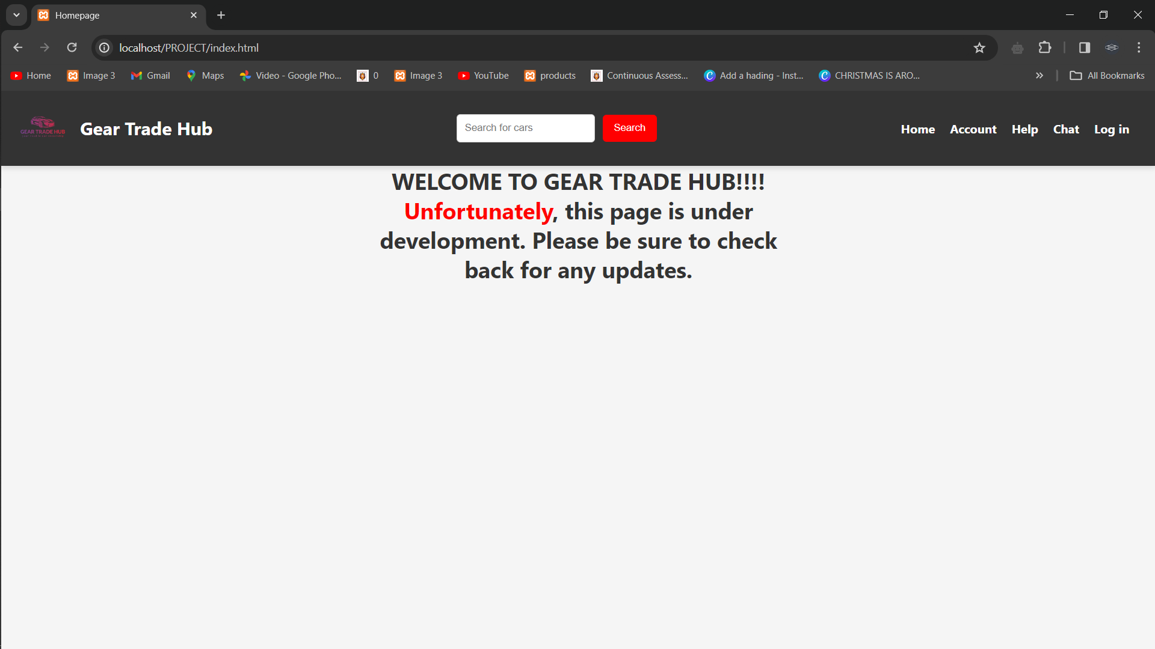

#### Main content

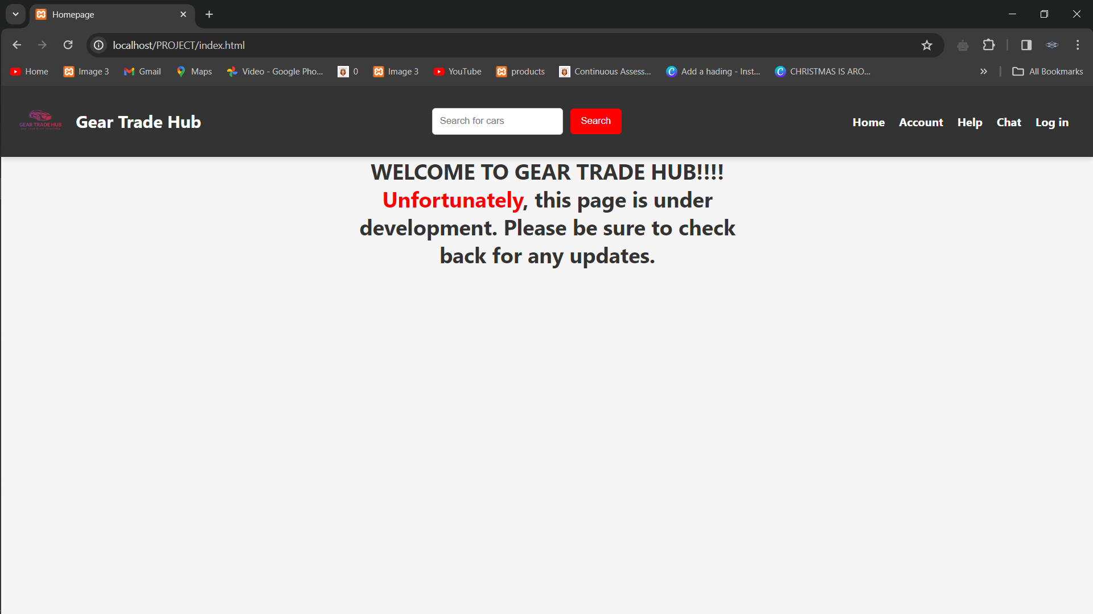

### **5.6.2 Login page**

#### Header section

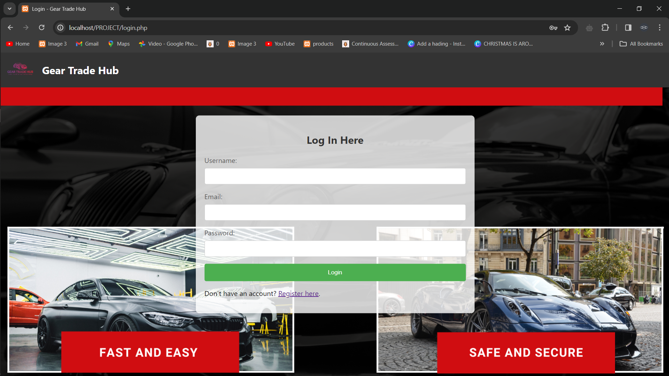

#### Main content



#### Error message

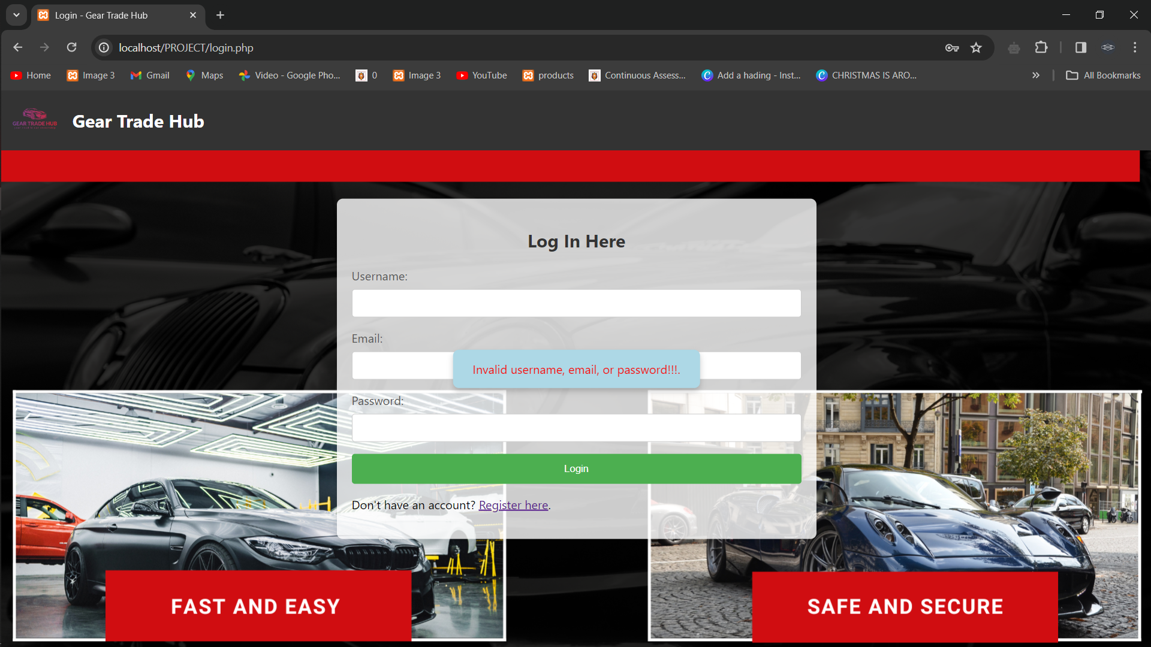

### **5.6.3 Registration page**

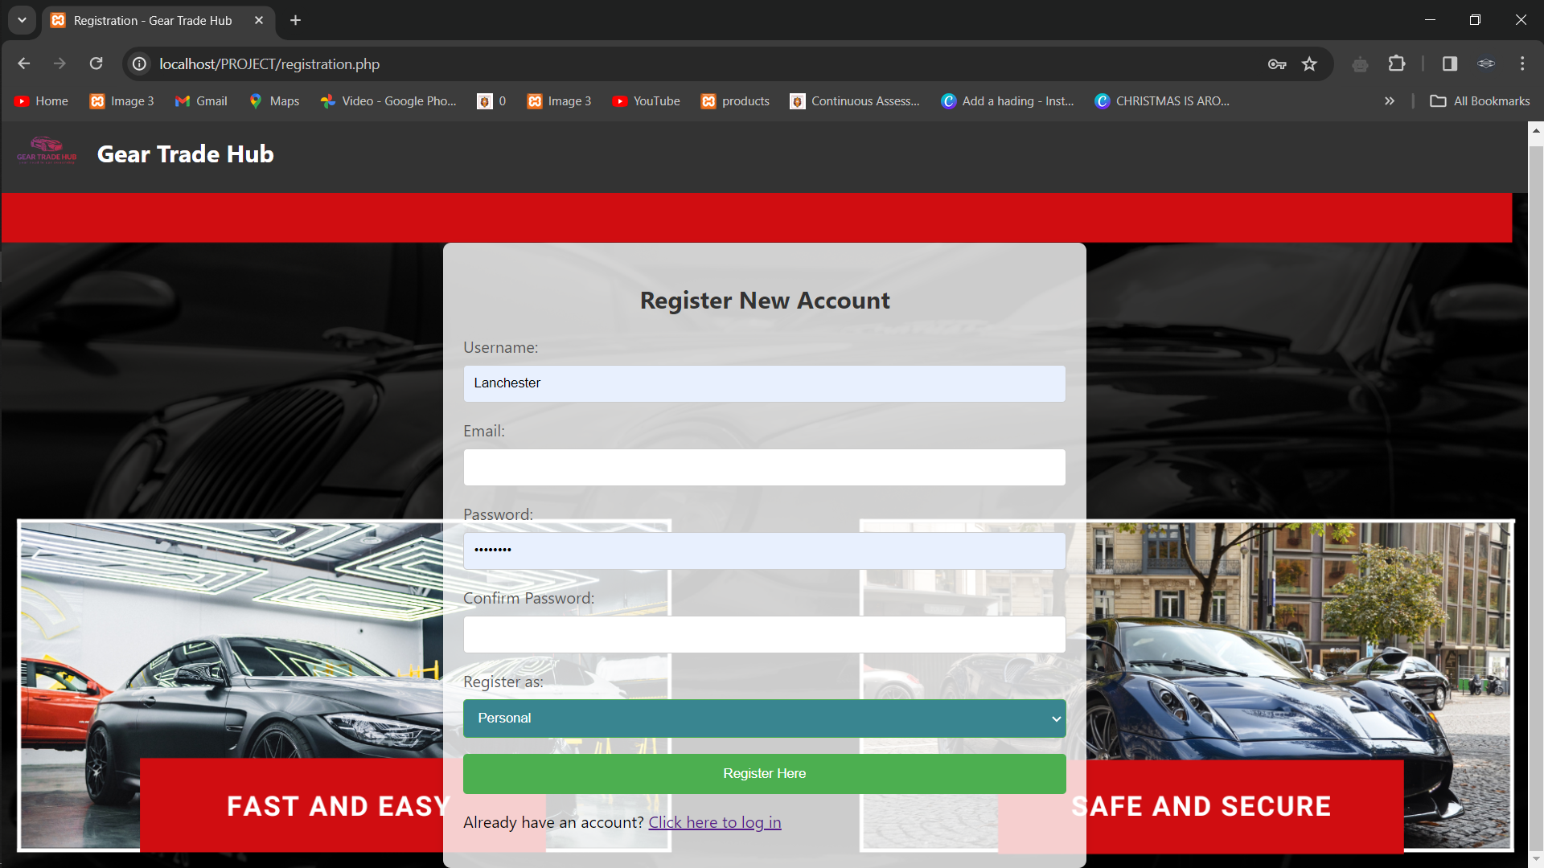

#### Main content



#### Input fields

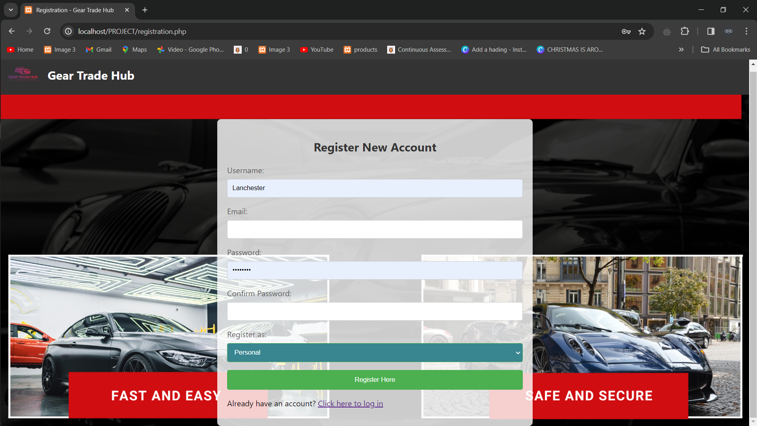

#### Personal user fields

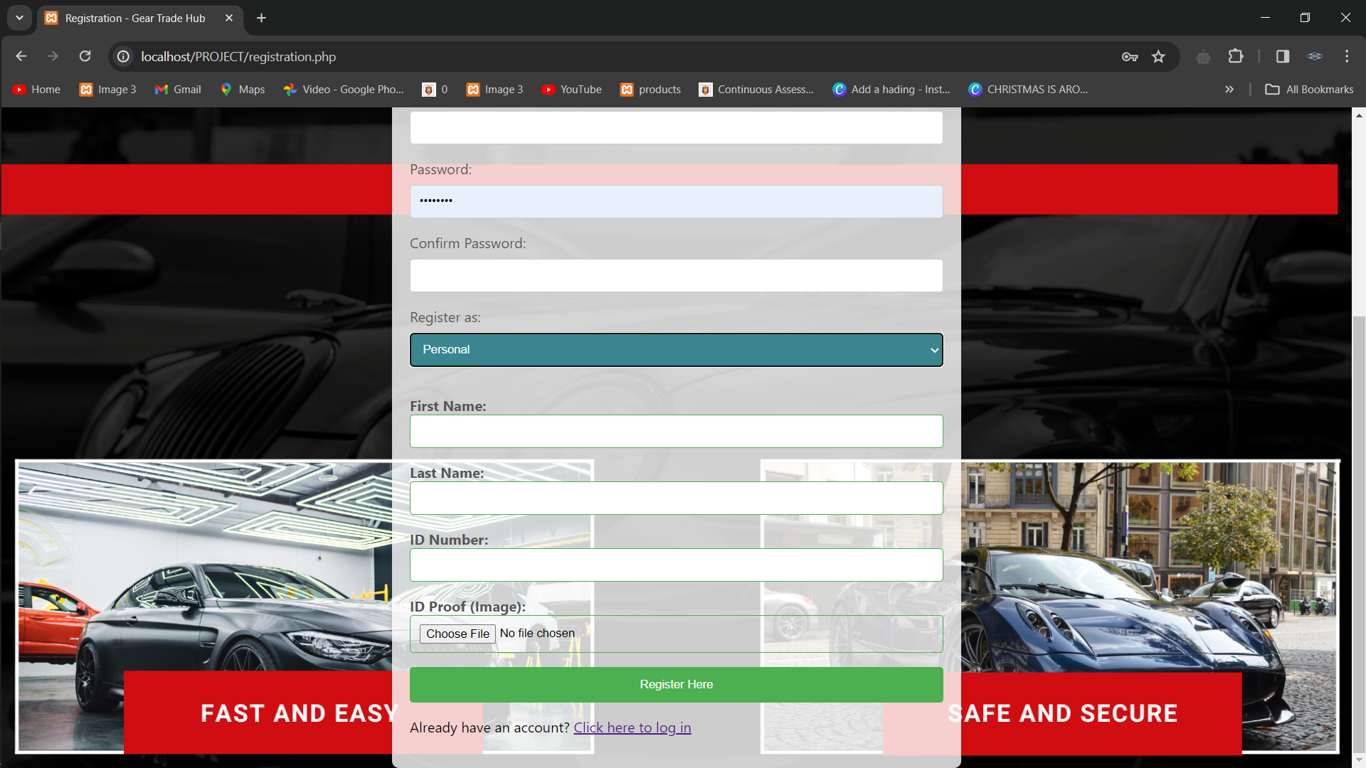

#### Showroom user fields

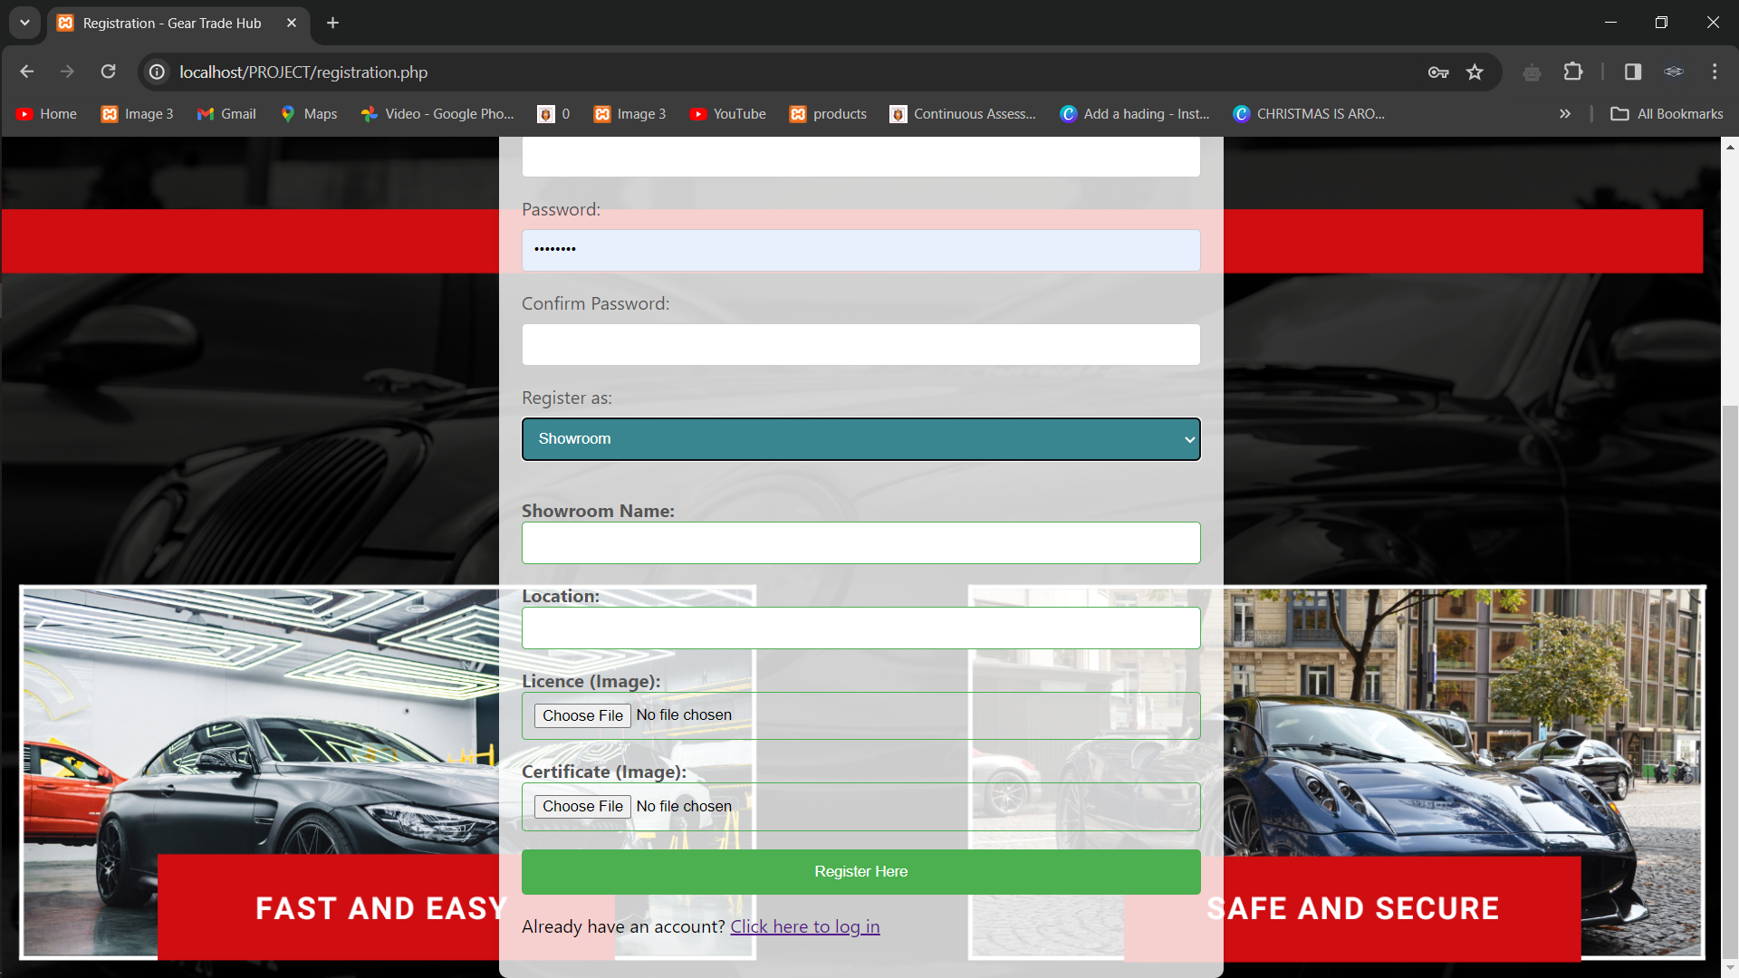

#### Error message

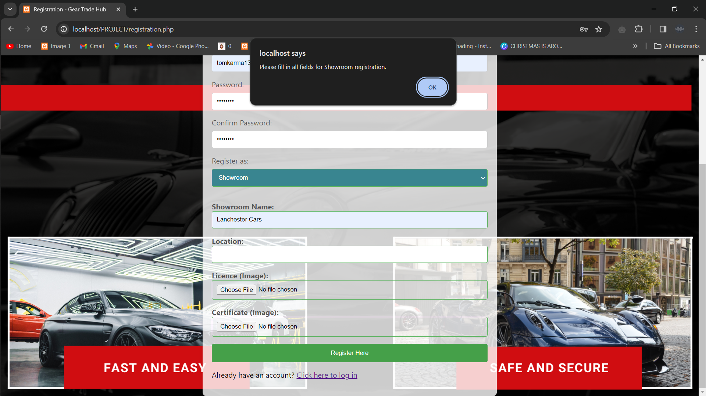

## **5.7 Test Data**

### 5.7.1 Login Test Data

#### Valid login

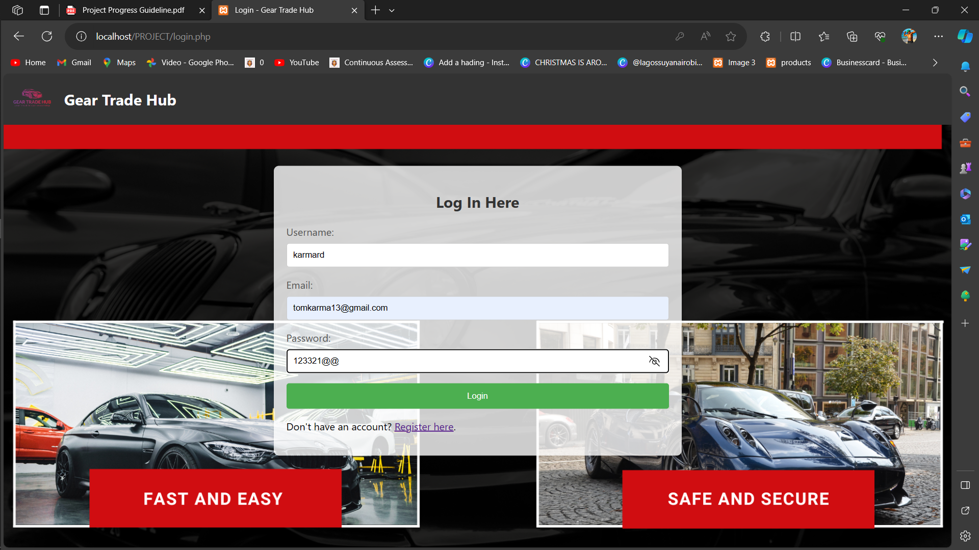

#### Invalid login

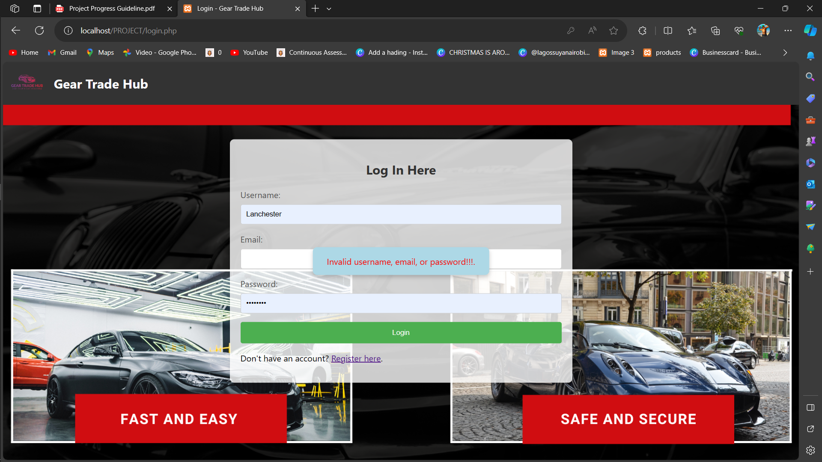

## **5.7 chapter summery**

In Chapter 5, the focus shifted towards the intricate design aspects of Gear Trade Hub, a platform poised to revolutionize the vehicle trading landscape. The chapter commenced with a comprehensive introduction, setting the stage for an in-depth exploration of the proposed system's architecture and processes.

The description of the proposed system was a pivotal section, offering a nuanced analysis of Gear Trade Hub's strengths and weaknesses. The conceptual architecture was meticulously examined, underlining its resilience and adaptability to cater to a diverse user base. This critical evaluation provided valuable insights into the system's potential and areas for refinement.The process design phase harnessed the power of both System and Object-Oriented System Analysis and Design (SSAD, OOSAD) tools. Flowcharts were employed to elucidate the intricacies of the login and registration processes. These visual representations served as blueprints for the subsequent development stages, ensuring a clear and structured approach to user interactions.Database design took center stage with the creation of an Entity-Relationship Diagram (ERD). This graphical representation delineated the relationships between key entities, offering a bird's-eye view of the underlying data structure. A meticulous data dictionary accompanied the ERD, providing a detailed guide to the attributes and relationships within the database.The I/O (Input/Output) section introduced mock-up screens for the homepage, login page, and registration page. These screens adhered to consistent branding elements and a user-friendly design, with placeholders for images, buttons, and other UI components. The focus was on responsive design principles to ensure optimal user experience across diverse screen sizes.Test data planning involved the generation of diverse scenarios to represent actual input conditions. These tests encompassed login attempts, registration processes, search functionalities, and transaction simulations. The goal was to comprehensively validate the system's functionality under various usage scenarios, preparing it for real-world deployment.

# CHAPTER SIX IMPLEMENTATION (SYSTEM PROTOTYPE)

**6.1Introduction**Chapter 6 marks a pivotal phase in the development of Gear Trade Hub as we transition from the planning and design stages to the actual implementation of the system prototype. This chapter focuses on bringing the envisioned system to life, with an emphasis on user interface implementation, database design, process implementation, and module testing. The primary goal is to create a functional system prototype that aligns with the outlined requirements and design specifications.

The implementation phase involves translating the conceptualized design elements into tangible features, providing users with a hands-on experience of Gear Trade Hub's functionalities. This chapter provides a comprehensive overview of the steps taken to transform design concepts into a working system, covering key aspects such as the user interface, database structure, and underlying processes.

As we delve into the intricacies of implementation, special attention will be given to the user interface, which serves as the bridge between users and the system. This includes the development of input forms, reports, and validation mechanisms, with a focus on ensuring a seamless and secure interaction for end-users. Additionally, the implementation of the Entity-Relationship Diagram (ERD) will be detailed, showcasing the structure and relationships within the database.

Furthermore, the chapter will explore the practical aspects of process design, illustrating how data is written to, read from, updated, and deleted within the system. This involves interactions with databases and files, providing a hands-on understanding of the system's functionality.To ensure the reliability and functionality of individual components, module testing will be conducted. This involves testing specific modules or units of the system in isolation, allowing for the identification and resolution of any issues before integration.

## **6.2 UI implemented with validation**

Implementation of the user interface (UI) for Gear Trade Hub takes center stage, ensuring that the design concepts are translated into functional and interactive components. The UI serves as the user's gateway to the system, providing input forms, reports, and validation mechanisms to enhance the overall user experience.

**6.2.1 Login Form:**The login form is a critical element of the UI, allowing users to securely access Gear Trade Hub. Input fields for username and password are implemented, and robust validation mechanisms are put in place. This includes confirming the authenticity of user credentials and providing error messages in case of login failures. The UI aims to create a seamless and secure login process for users.

**6.2.2 Registration Form:**Another pivotal UI component is the registration form, enabling new users to sign up for Gear Trade Hub. The form incorporates input fields for username, email, password, and additional fields based on user type (Personal or Showroom). During implementation, stringent validation is applied to ensure accurate data entry. Error messages are displayed to guide users in case of any issues, fostering a user-friendly registration process.

**6.2.3 Input Forms:**Various input forms are implemented to capture user input for specific functionalities. These forms align with the system's requirements and facilitate the addition of new cars, processing payments, sending messages, and other essential features. Each input form is designed to be intuitive and user-friendly, with validation mechanisms preventing incorrect or malicious data entry.

**6.2.4 Reports:**The UI includes reports to provide users with insightful data representations, such as transaction history, sales reports, and more. These reports are designed to be accessible and comprehensible, enhancing the user's ability to monitor and analyze their activities on Gear Trade Hub.

**6.2.5 Validation Mechanisms:**Validation plays a pivotal role in maintaining data accuracy and system security. Input fields across various forms are subjected to validation to prevent incorrect or unauthorized data entry. For instance, the login form undergoes validation to verify user credentials, while registration forms validate user inputs to uphold data quality standards.

## **6.3 ERD implementation with all relevant tables created**

In the development of Gear Trade Hub, the Entity-Relationship Diagram (ERD) serves as a fundamental component, illustrating the relationships between different entities and their attributes within the system. The ERD provides a visual representation of the database structure, ensuring that all relevant tables are created to support the functionality and data requirements of the application.

**Users Table:**The Users table is at the core of the ERD, representing essential user information. It includes fields such as UserID (primary key), username, email, password, and usertype. This table establishes relationships with other tables to capture diverse user data based on their roles.

**PersonalLog Table:**The PersonalLog table is linked to the Users table through the UserID as a foreign key. This table is specific to users with a 'personal' usertype, storing additional information such as IDNo, IDproof, pFname, pLname, and other personal details.

**ShowroomLog Table:**For users with a 'showroom' usertype, the ShowroomLog table captures information like showname, location, licence, certificate, and other relevant details. It is connected to the Users table through the UserID as a foreign key.

#### Erd diagram

|  |
| --- |
| showroomlog |
| UserID(FK) |
| username(PK)  N |
| Email(PK) |
| showname |
| location |
| licence |
| certificate |
| password |

|  |
| --- |
| personallog |
| UserID(FK)  1 |
| username(PK) |
| Email |
| IDNo(PK) |
| IDProof |
| pFname |
| pLname |
| password |

|  |
| --- |
| Users |
| UserID(PK) |
| username |
| email |
| password |
| usertype |

N

1

## **6.4 Process design**

In the realm of Gear Trade Hub, the process design orchestrates a seamless flow of operations, commencing with user registration. When a user opts to register, they engage with the registration form, furnishing essential details contingent on their user type—be it Personal or Showroom. This process includes the collection of standard information such as username, email, and password.

For Personal users, additional personal details are gathered along with an uploaded ID proof image. Conversely, Showroom users furnish showroom specifics and upload a license and certificate image. The collated data is judiciously stored in the corresponding tables within the database, such as Users, PersonalLog, or ShowroomLog. The management of file uploads involves storing file paths in the database and saving the files in an allocated directory.

Subsequently, the user login process ensues, wherein the system validates user credentials. Upon entering their username and password, the system cross-checks the provided details against the stored data in the Users table. If the credentials align, access is granted; otherwise, an error message is presented. Beyond this, users have the capability to modify their data or delete their accounts. Updates are facilitated through dedicated forms, leading to corresponding database record adjustments. Account deletions initiate a process that expunges the user's data from the database.

For data retrieval, users can access their information or execute searches for specific details, culminating in the system fetching pertinent data from the database based on user queries. Additionally, file handling is integral, with uploads stored in a predefined directory and file paths referenced in the database. This enables the system to retrieve and exhibit these files upon user requests.

## **6.5 Module testing**

In the implementation phase of Gear Trade Hub, rigorous module testing is essential to validate the integrity and functionality of individual components. Specifically, we will focus on the testing of the user authentication module, which includes the crucial functionalities of user login and registration.

The login functionality undergoes comprehensive testing, covering both positive and negative scenarios. In positive testing, the system is evaluated for successful authentication when provided with valid user credentials. Conversely, negative testing involves intentionally inputting invalid credentials to assess the system's response to unauthorized access attempts. The expected outcome is a seamless login process for valid users and appropriate error messages for invalid attempts.

For the registration functionality, a thorough examination of input validation is conducted. This ensures that mandatory fields are correctly filled, and data formats adhere to predefined criteria, thereby maintaining data integrity. Additionally, the system's ability to differentiate between user types (Personal or Showroom) during registration is scrutinized, ensuring accurate categorization and storage of user data in the respective tables (PersonalLog or ShowroomLog).

Error handling testing is an integral part of module testing, where the system's response to unexpected scenarios, such as server errors or connectivity issues, is assessed. This ensures users receive clear and informative error messages in case of unforeseen circumstances.Security testing is another crucial aspect, focusing on measures like password encryption to safeguard sensitive user information. The system's performance is evaluated under various conditions through load testing, ensuring responsiveness during concurrent login or registration attempts, especially during peak usage.

Session management testing examines the system's ability to handle user sessions securely, considering scenarios where users remain inactive for extended periods or attempt to access pages without proper authentication. Compatibility testing across different browsers and devices is also performed to guarantee a consistent user experience.

## **6.6 Chapter Summery**

Chapter 6 of Gear Trade Hub's development journey concludes with significant achievements. The chapter commenced with an introduction, setting the stage for the implementation of the system prototype. The focus shifted towards the User Interface (UI) implementation, encompassing the creation of input forms and reports with meticulous validation mechanisms. Key components such as the login and registration forms were highlighted, emphasizing the importance of data validation and error handling.

The subsequent section delved into the Entity-Relationship Diagram (ERD) implementation, elucidating the relational structure between the Users, PersonalLog, and ShowroomLog tables. The ERD visually represented the relationships, ensuring a clear understanding of the database architecture.

Moving forward, the process design was explicated, emphasizing the implementation of core functionalities such as writing, reading, updating, and deleting data in the database. The focus on these operations ensures the robustness and versatility of Gear Trade Hub's backend.

The module testing phase took center stage, specifically concentrating on the authentication module. Testing scenarios were meticulously outlined, encompassing positive and negative testing, input validation, error handling, security testing, and performance evaluation. The successful demonstration of module testing showcased the reliability and security of the user authentication module.

# References/Bibliography

Brown, A. (2020, June 10). Navigating the Online Car Buying Process. AutoInsights Online. <https://www.autoinsights.com/navigating-online-car-buying>

National Highway Traffic Safety Administration. (2021). Annual Report on Online Vehicle Sales Regulations. U.S. Department of Transportation. <https://www.nhtsa.gov/reports/online-vehicle-sales>

Autotrader. (n.d.). Used Cars for Sale. Autotrader. <https://www.autotrader.com/>

Cars.com. (2022, November 27). New & Used Cars. Cars.com. <https://www.cars.com/>

Edmunds. (2022, November 27). New Cars, Used Cars, Car Reviews and Pricing. Edmunds. <https://www.edmunds.com/>

Kelley Blue Book. (2022, November 27). New & Used Car Prices. Kelley Blue Book. <https://www.kbb.com/>

TrueCar. (2022, November 27). New & Used Cars for Sale. TrueCar. <https://www.truecar.com/>

Carmax. (2022, November 27). Browse Used Cars and New Cars Online. Carmax. <https://www.carmax.com/>

Autoblog. (2022, November 27). New Cars, Used Cars for Sale, Car Reviews and Car News. <https://www.autoblog.com/>

CarsDirect. (2022, November 27). Cars for Sale - Buy a New or Used Car Online. CarsDirect. <https://www.carsdirect.com/>

# Appendix

#### Sample questionnaire

Gear Trade Hub User Feedback QuestionnaireThank you for taking the time to provide your valuable feedback. Your input is essential for enhancing the Gear Trade Hub platform. Please answer the following questions honestly and to the best of your knowledge.1. Personal Information:Name: ________________Email: ________________User Type: Personal User Showroom OwnerHow did you hear about Gear Trade Hub? Online Advertisement Social Media Word of Mouth Other (please specify): ________________2. User Experience:On a scale of 1 to 5, how would you rate your overall experience using Gear Trade Hub? (1 - Poor, 5 - Excellent) 1 2 3 4 5What features do you find most useful on Gear Trade Hub?Are there any specific challenges or issues you've encountered while using the platform?3. Interface and Design:Rate the user interface design: Not User-Friendly Somewhat User-Friendly Moderately User-Friendly Very User-Friendly Extremely User-FriendlyAre there any suggestions for improving the design or layout?4. Features and Functionality:Which features do you believe are missing and would enhance your experience?Are there any features you find unnecessary or confusing?5. Security and Privacy:How confident are you in the security of your personal information on Gear Trade Hub? Not Confident Somewhat Confident Moderately Confident Very Confident Extremely ConfidentAny additional comments or concerns about privacy and security?6. Suggestions:Do you have any additional comments, suggestions, or feedback regarding Gear Trade Hub?Thank you for your participation! Your feedback is invaluable in shaping the future of Gear Trade Hub.

#### Sample budget schedule

|  |  |  |  |
| --- | --- | --- | --- |
| # | ITEM | QUANTITY | PRICE |
| 1 | HP X360 LAPTOP | 1 | Ksh. 65,000 |
| 2 | SMART PHONE | 1 | Ksh. 60,000 |
| 3 | SMART TV | 1 | Ksh. 25,000 |
| 4 | PRINTING |  | Ksh. 2,500 |
| 5 | TRANSPORT |  | Ksh. 3,000 |
| TOTAL | Ksh. 155,000 |

#### Sample code for registration fields

